III WORLD CONGRESS OF TRANSDISCIPLINARITY
Virtual mode
From October 30, 2020 to October 15, 2021

International Center for Research and Transdisciplinary Studies
(CIRET-France)

National School of Anthropology and History
National Institute of Anthropology and History
(ENAH/INAH-Mexico)

Transdisciplinary Education Center
(CETRANS-Brazil)

Transdisciplinary UNESCO Chair
Human Development and Culture of Peace from the University of Florence
(CTU-Italy)

ACTIVITY PROGRAM

SCHEDULES
WEDNESDAY: 10:00 TO 13:00 hrs. (FROM MEXICO)
FRIDAY: 10:00 TO 13:00 hrs. (FROM MEXICO)

ATTENTION!
*DAYS WITHOUT ACTIVITIES FOR VACATION PERIODS*

END OF THE YEAR VACATIONS
*FROM DECEMBER 14, 2020 TO JANUARY 10, 2021*

CARNIVAL AND WEDNESDAY ASH
*FROM FEBRUARY 13 TO 17, 2021*

HOLY WEEK (1 WEEK)
*FROM MARCH 28 TO APRIL 3, 2021*

COLOR CODE ORGANIZING COMMITTEES

ANCESTRAL CULTURES, LATIN AMERICA

CETRANS, BRASIL

CIRET, FRANCE

CTU (UNESCO), ITALY

INAH/ENAH, MEXICO

REFICA, AFRICA

REDES, AFRICA

SEVERAL COUNTRIES

FRIDAY, OCTOBER 30, 2020

10:00 hrs.
INAUGURATION WITH THE FOUR INTERNATIONAL COMMITTEES
Moderator: Mirza Mendoza Rico, INAH

DIEGO PRIETO H. INAH General Director, Mexico
BASARAB NICOLESCU. CIRET, France
PAOLO OREFICE. CTU, Italy
MARIA FERNÁNDEZ DE MELLO. CETRANS, Brasil
FRÉDÉRIC VACHERON. Representative of UNESCO, Mexico

11:00 hrs.
KEYNOTE LECTURE
"TRANSDISCIPLINARITY AND THE FUTURE OF CIVILIZATION
Basarab Nicolescu
CIRET, France
Comments, 11:45 hrs.

12:00 hrs.
KEYNOTE LECTURE
“COGNITIVE SPIRALS OF TRANSDISCIPLINARITY.
CONTEMPORARY WORLD CHALLENGES”
Julieta Haidar
ENAH, Mexico
Comments, 12:45 hrs.

WEDNESDAY, NOVEMBER 4, 2020

INAH, MEXICO
TRANSCULTURALITY AND CULTURAL DIVERSITY IN MEXICO
Moderator: Mirza Mendoza Rico. INAH, Mexico.

10:00 hrs.
KEYNOTE LECTURE
“THE CONCEPT OF ART AMONG ZAPOTECS”
Natalia Toledo. Zapoteca.
Federal Culture Secretary, Mexico

11:00 hrs.
KEYNOTE LECTURE
“PERMEABLE IDENTITIES AND TRANSDISCIPLINARITY”
Diego Prieto Hernández
INAH, México General Director

12:00 hrs.
KEYNOTE LECTURE
“MEXICAS TEMPLO MAYOR:
AN INTER AND TRANSDISCIPLINARY PROJECT”
Eduardo Matos Moctezuma
Templo Mayor Project Coordinator, INAH, Mexico

FRIDAY, NOVEMBER 6, 2020

ENAH, MEXICO
TRANSCULTURALITY AND CULTURAL DIVERSITY IN MEXICO

SYMPOSIUM
"TRANSDISCIPLINARY MODELS FOR ANALYSIS OF ANCESTRAL CULTURES"
Moderator: María Eugenia Flores Treviño

"Identity Trans Dimensionality of Conchera Dance in San Diego, California neighborhoods ".
José Luis Valencia González. ENAH/ICONOS, Mexico.

"Community ritual aesthetics: from ancestral epistemes, in complexity and transdisciplinarity".
Marisol Cárdenas Oñate. ENAH, Mexico.

"Aesthetics-rituals-community-decolonial: a model for cross-cultural analysis".
David Terrazas Tello. ENAH, Mexico.

“Complexity, memory and transdisciplinarity. The defense of Mother Earth in the Acolhua region against the imposition of urban projects ".
Oscar Ochoa Flores. ENAH, Mexico.

“Memory of the insurrectionist culture in rooted documentary cinema. A model of transdisciplinary analysis”.
Isabel Galindo Aguilar. ENAH, Mexico.

WEDNESDAY, NOVEMBER 11, 2020

REFICA, AFRICA
THE PEACE

KEYNOTE LECTURE
"‘SANANGOUYA’ OR ALLIANCES TO PLEASURE: A VECTOR OF PEACE"
Mèkè Meite
Chaire UNESCO pour la culture de la paix de l'Université Felix Houphouët-Boigny, Ivory Coast.

ROUND TABLE
“THE CULTURE OF PEACE”
Moderator: Federico Mayor Zaragoza.
Culture of Peace Foundation, Spain.

"African Peace & Security Architecture (APSA): Efficacy of Subsidiarity in Peace Support Operations".
Willie Eselebor

"Africa and the culture of peace".
Jean-Noël Loucou

FRIDAY, NOVEMBER 13, 2020

REFICA, AFRICA
THE PEACE

SYMPOSIUM
“PEACE AND DEVELOPMENT PERSPECTIVES”
Moderator: Edouard Firmin Matoko
Sous-Directeur Général
Priority Africa and External relations UNESCO, Paris

"African Peace & Security Architecture (APSA): Efficacy of Subsidiarity in Peace Support Operations".
Willie Eselebor

"Prospect for Peace and Development".
Migyikra Erasmus

"Prospect for Peace and Development".
Aboudou Soro N’golo

"Sanangouya» ou alliances à plaisanteries : un vecteur de paix".
Mèkè Meite

WEDNESDAY, NOVEMBER 18, 2020

CIRET, FRANCE
TRANSDISCIPLINARY RESEARCH AND EDUCATION
Moderator: Florent Pasquier

KEYNOTE LECTURE
"HOW TO OPERATIONALIZE TRANSDISCIPLINARY PEDAGOGY"
Florent Pasquier. Sorbonne University, Paris, France.

KEYNOTE LECTURE
"HOW TO OPERATIONALIZE TRANSDISCIPLINARY RESEARCH"
Javier Collado Ruano. Cuenca University, Ecuador.

ROUND TABLE
TRANSDISCIPLINARY RESEARCH AND EDUCATION
"Transdisciplinary being: a univocal curriculum of self-cultivation"
Paul Gibbs. Middlesex University, London, England.

"A Note on Transdisciplinary Thinking".
Raymond Yeh. Austin Texas University, EUA.

"Astronomy as a transdisciplinary approach to science education in all levels”.
Magda Stavinschi. Iași, Romania.

NOVEMBER 20, 2020

CIRET, FRANCE
SYMPOSIUM
“TRANSDISCIPLINARY RESEARCH AND EDUCATION”
Moderator: Florent Pasquier

1. EDUCATION/ENSEIGNEMENT

"Environmental education from the reflections of implicative and integrative pedagogy".
Samuel Pinheiro. Federal University of Rio Grande, Brazil.

"The Miracle of Transdisciplinarity - Perspectives from an Eastern European Educational System".
Bertea Mircea. “Babeș-Bolyai” University from Cluj, Rumania.

"Transdisciplinary approach to self-training: levels of self-reality and formative interactions".
Pascal Galvani. Quebec University in Rimouski, Canada.

2. MEDICINE / CARE

"From artificial intelligence to the human heart: a clinical perspective in technological and health curricula".
Katia Mendez. Paris 8 University, France.

"Contributions to transdisciplinary perspective in the health sector".
Pauline Lenesley. Caen University, France.

“Mains dans les mains : un vécu transdisciplinaire en soins palliatifs et yoga".
Mariana Thieriot-Loisel. Canada.

3. TRANSMISSION / SEARCH

"Transdisciplinary library".
Juan-Bouysset Raphaël. Maisons-Laffitte Library, France.

"Culture and psyché. The question of borders and the transdisciplinary approach".
Houria Abdelouahed, Paris-Diderot University, France.

"Assessment and Variability of Research in Transdisciplinarity: International meta-analysis".
Jean Frayssinhes. Toulouse Jean-Jaurès University, France.

"The Trans is Elsewhere".
José Oliveira. Évora University, Portugal.

WEDNESDAY NOVEMBER 25, 2020
CTU, ITALY
CITIZENS OF EARTH
HUMAN FRAGILTY AND POST-PANDEMIC SPECIES COMMUNITY
Week I. Transdisciplinary Vision
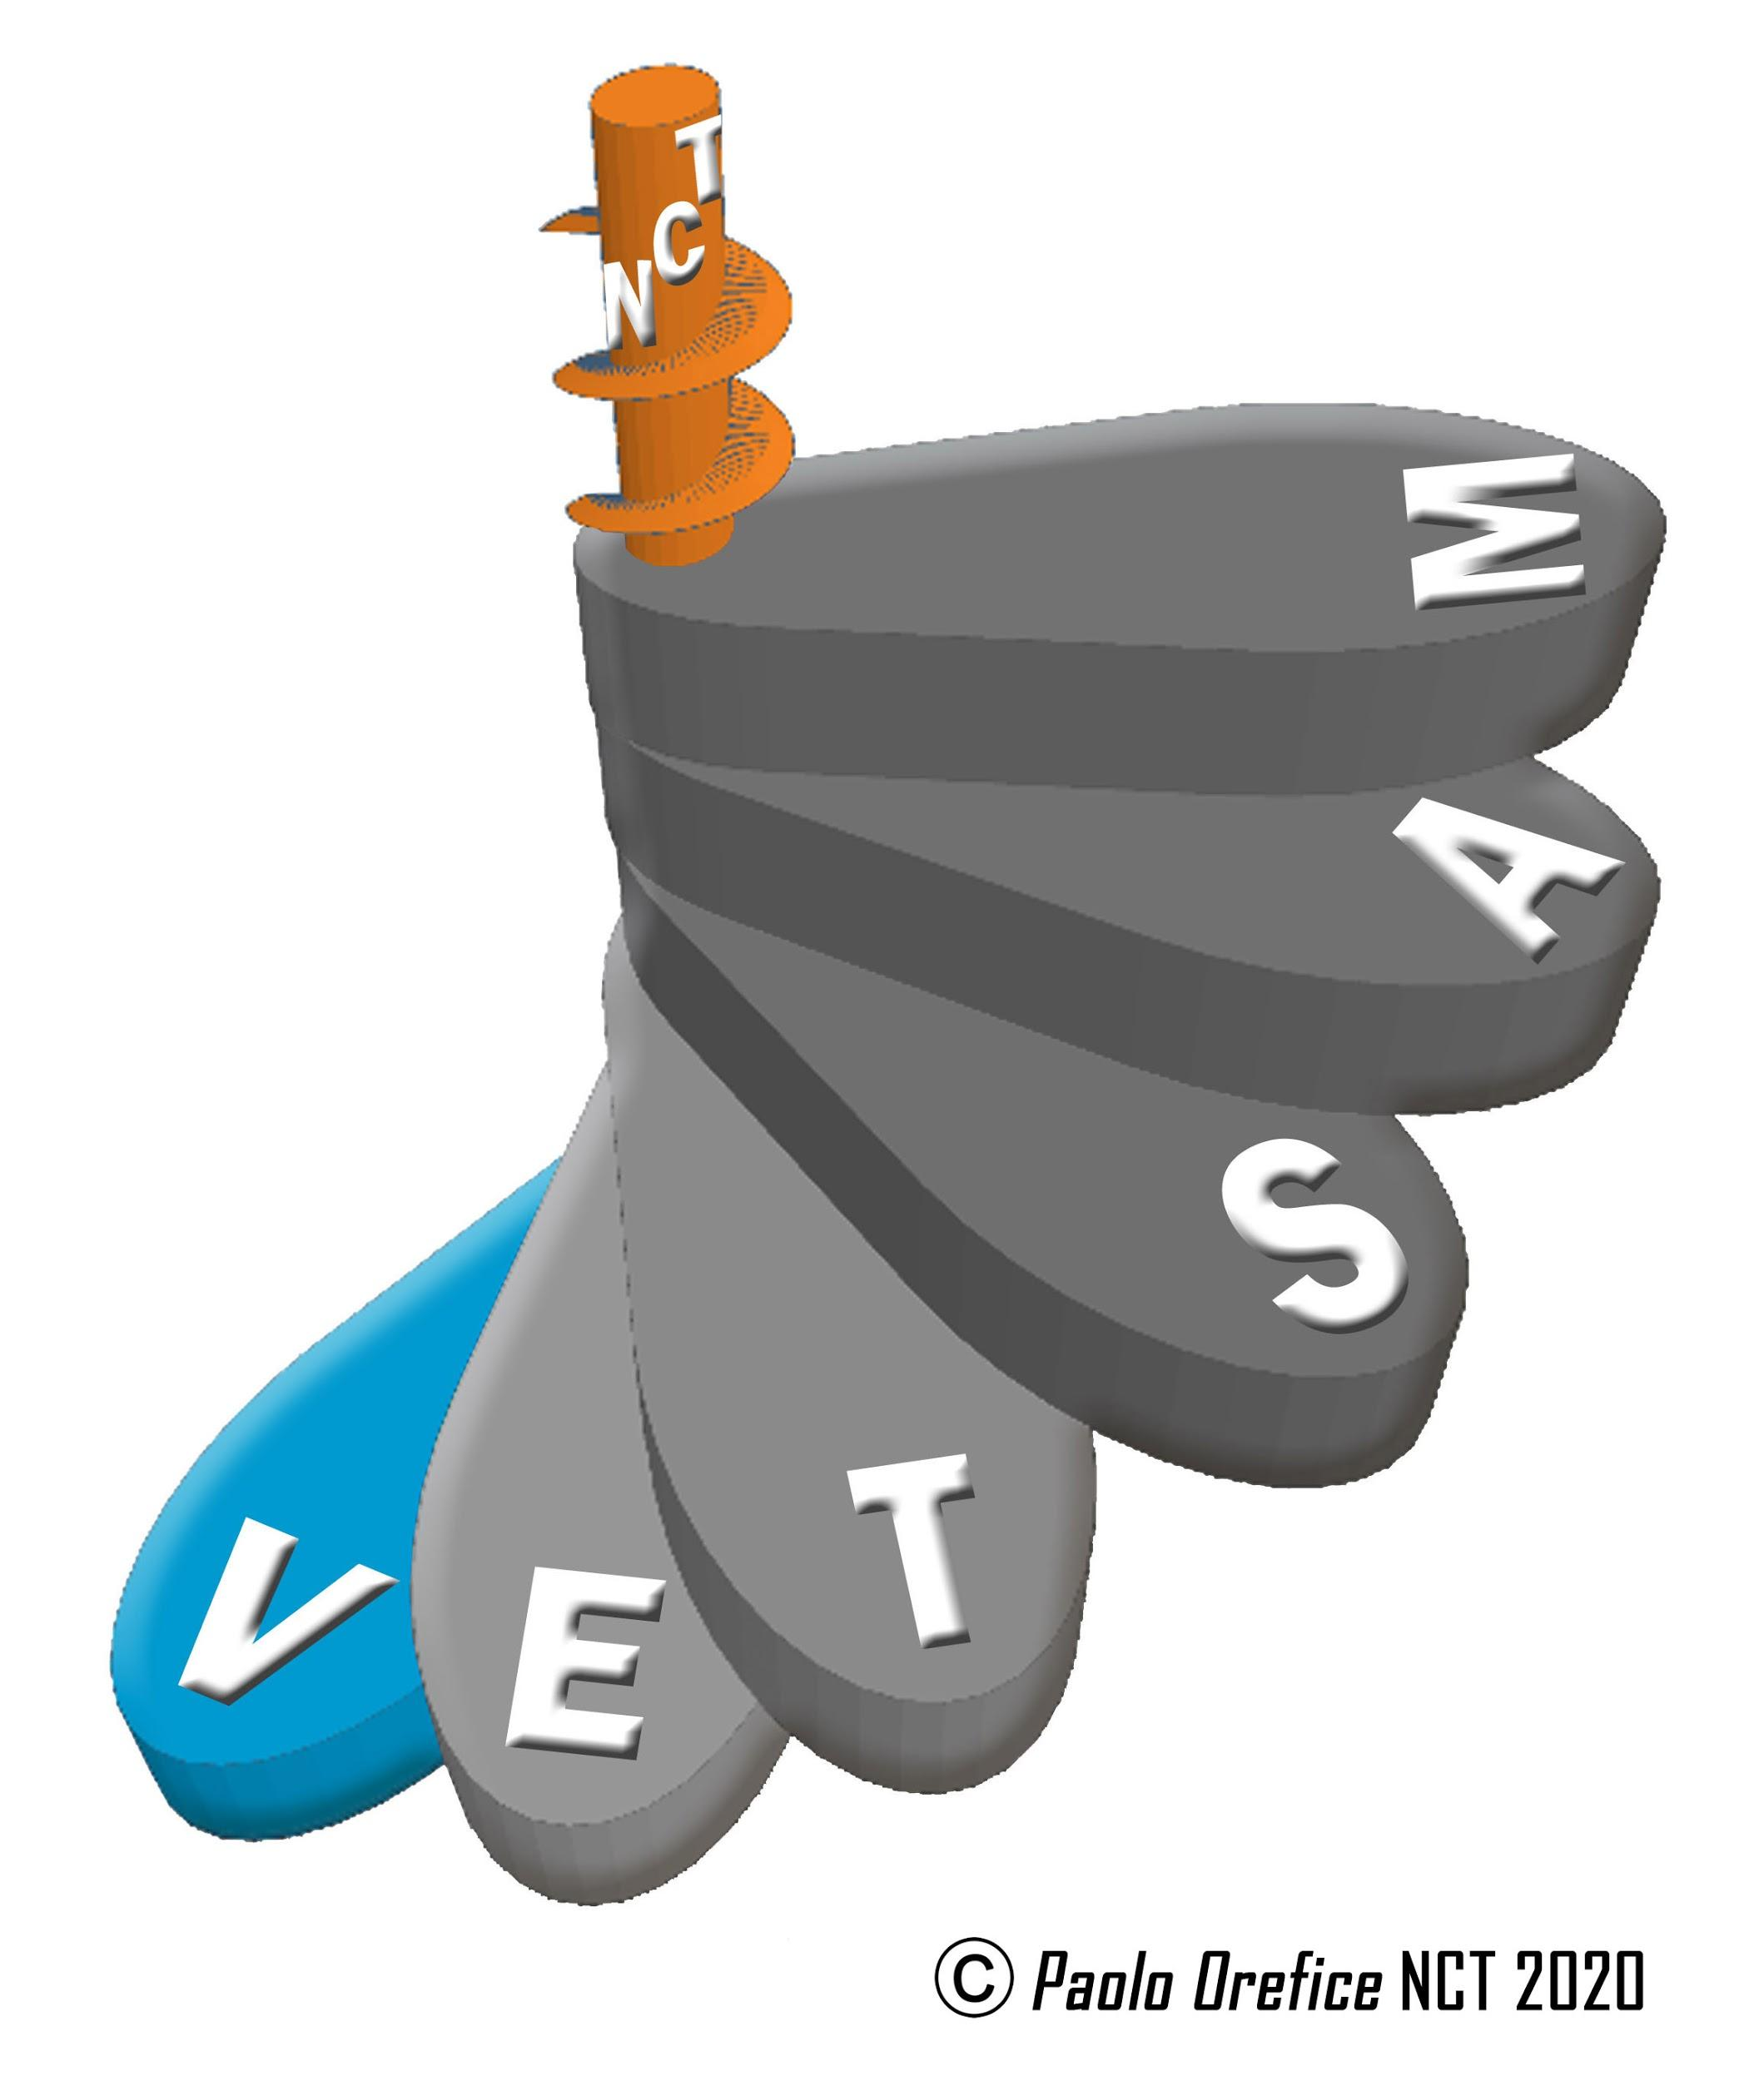
Opening and presentation of the Week
Luigi Dei. Rector, Universidad de Florencia, Italia.
Moderator: Alberto Peruzzi. University of Florence, Italy.
KEYNOTE LECTURE
"LOOKING BEYOND: RETURN TO MOTHER EARTH OR TOWARDS THE EXTINCTION OF SPECIES"
Paolo Orefice, CTU / Florence University, Italy.

KEYNOTE LECTURE
"HUMANISM-ECOHUMANISM: CITIZENS OF THE EARTH"
Mauro Ceruti. IULM, Italy.
ROUND TABLE
"THE VALUES OF THE CITIZENS OF THE EARTH: COMMON AND DIFFERENT FEELINGS"

"The values of the citizens of the Earth".
Alberto Peruzzi. University of Florence, Italy

"Feelings of citizenship: experiences in Chile"
Tamara Madariaga Venegas. Adjunta Cátedra CTU, University of Florence, Italy /University Santiago de Chile, Chile.

"Feelings of citizenship: experiences in Nicaragua".
Jessica Pérez Reynosa. Interdisciplinary Institute of Social Sciences / Universidad Centroamericana, Nicaragua.

Hellen Castillo Rodríguez. Interdisciplinary Institute of Social Sciences / Universidad Centroamericana, Nicaragua.

FRIDAY, NOVEMBER 27, 2020

CTU, ITALY
CITIZENS OF EARTH
Human fragility and post-pandemic species community

SYMPOSIUM
“TRANSDISCIPLINARY EDUCATION FOR THE CITIZENS OF THE EARTH. LEARN FROM THE PANDEMIC ".
Presentation: Paolo Orefice. UNESCO C. Florencia University, Italy.
Moderator: Carla Guetti

"Education for planetary citizenship: the experience of UNESCO associated schools in Italy".
Carla Guetti. Ministry of Education - Italy / National Coordinator Network of UNESCO Associated Schools, ASPnet.

Julie Saito-Loubiere. International Coordinator Network of Associated Schools UNESCO,

ASPnet. Associated Schools UNESCO - ASPnet (Italy):

"We will overcome Covid: a renewed sociality and terrestrial sustainability". Mirella Spinelli (Director), Lorella Di Campli (IC Mario Bosco - Lanciano, Chieti)

"Transdisciplinary education: cooperation and solidarity for a global citizenship".
Tiziana Faggiano (Director), Antonia Martina (Direction Didactics 4 Circle Sigismondo Castromediano-Lecce).

"Global citizenship in transdisciplinary education".
Elena Zacchilli (Director), Maria Rosaria Fasanelli (Liceo Niccolò Machiavelli-Roma).

"Citizens of the Earth and Cultural Heritage in times of Covid".
Rosella Uda (Director), Annalisa Marongiu (IIS G.A. Pischedda-Bosa, Oristano).

WEDNESDAY, DECEMBER 2, 2020

CETRANS, BRASIL
HEALTH AND TRANSDISCIPLINARITY
Moderator: Americo Sommerman

KEYNOTE LECTURE
“TRANSDISCIPLINARITY AND HEALTH. ARTICULATION BETWEEN PHENOMENOLOGY AND ONTOLOGY
Patrick Paul

ROUND TABLE
“INTEGRATIVE CARE: TRANSDISCIPLINARY EXPERIENCES IN HEALTH”

“Experiences in the 1st Sector: Public".
Sissy Veloso Fontes

“Experiences in the 2nd Sector: Private".
Eleonora Lins

“Experiences in the 3rd. Sector: Philanthropic Institutions”.
Monica de Medeiros

FRIDAY, DECEMBER 4, 2020

CETRANS, BRASIL
HEALTH AND TRANSDISCIPLINARITY
Moderator: Daniel Silva
Federal University of Santa Catarina

SYMPOSIUM
“A HEALTHY HUMANITY POST COVID-19”

"The Resilience of Humanity on Planet Earth".
Martha de Lima.

"Integral Human Being Health: Individual, Collective and Environmental".
Juliara Hoffmann.

"Humanizing Economics: Respecting People and Nature".
Fernanda Silva.

"The presence of an Aggregating Feminine Principle to all Phenomena”
Gabriele Vanessa.

WEDNESDAY, DECEMBER 9, 2020
REDES, AFRICA/AMERICA
DECOLONIZATION
PRESENTATION
Ousmane Aly Palm. President REDES AFRICA, Senegal

KEY NOTE LECTURE
“DECOLONIZATION, A PLANETARY HISTORICAL FACT”
Lamine Mané Mouhamadou. REDES AFRICA, Senegal
Moderator: Abdoualye Konte. REDES AFRICA, Senegal

KEY NOTE LECTURE
"DECOLONIZATION AND IDENTITY OF THE PENINSULAR MAYAN PEOPLE"
Fidencio Briceño Ch’el, INAH de Mérida, México
ROUND TABLE
"CONFLICT: COLONIZATION AND DECOLONIZATION IN THE RDC"
Moderator: Godefroid Pakabomba Muabi
"Congolese conflicts. Complex processes".
Godefroid Pakabomba Muabi

“From the cult of life, to the life of reason in recurring conflicts in the RDC ".
Ntumbua Tshipamba

"Elections and anti-power in the RDC. The vote of the invisible".
Marco Antonio Reyes Lugardo

"The RDC: War, Strategic Minerals, and the Recruitment of Infants".
Omer Buatu Batubengev

"Childhood and youth in the Congolese conflict".
Merveille Lembelembe Mbuyi

FRIDAY, DECEMBER 11, 2020

AFRICA/AMERICA
DECOLONIALITY

SYMPOSIUM
"“ANALYSIS OF DECOLONIZATION IN AFRICA AND
IN LATIN AMERICA
Moderator: Paolo Orefice, UNESCO Transdisciplinary Chair,
University of Florence, Italy.

"The forms of decolonization across Africa: violent form".
Amadou Demba Diallo

"The forms of decolonization through Africa: peaceful way".
Youssou MBOUP

Debates on decolonization in the Nicaraguan Miskita".
José Miguel González Perez. York University, Canada (Nicaragua).

Ruth Matamoros Mercado. University of Austin, Texas (Nicaragua).

Resistance of the Naayeris since colonization"
Pedro Cayetano González. Councilor Nayeri before the National Indigenous Congress, Mexico.

"Naayeri people, between conflict of territorialities and production of alterhegemony".
Carlos Rafael Rea Rodríguez, Autonomous University of Nayarit, Mexico.

"Approaches from interculturality and its perspective in contexts of inequality from the Mayan zone".
Ever Marcelino Canul Góngora, University of Quintana Roo, Mexico.

WEDNESDAY, JANUARY 13, 2021

PUIC (UNAM), MEXICO
TRANSDISCIPLINARY EDUCATION
Moderator / Commentator: Rafael Pérez Taylor
KEY NOTE LECTURE
"THE PROCESSES OF DEMOCRATIZATION OF SOCIETY IN THE 21ST CENTURY. UNIVERSITY AND INDIGENOUS PEOPLES"
José del Val, PUIC UNAM

ROUND TABLE
"CULTURAL DIVERSITY AS A TRANSDISCIPLINARY AXIS IN THE FRAMEWORK OF THE MÉXICO NACIÓN MULTICULTURAL PROJECT"
Moderator: Carolina Sánchez García

"Diversity and interculturality at UNAM".
José del Val, PUIC-UNAM, Mexico.

"Indigenous Rights in Mexico".
Elia Avendaño Villafuerte. PUIC-UNAM, Mexico.

"Afro-Indianness in Latin America and the Caribbean".
Juan Pablo Peña Vicenteño. PUIC-UNAM, Mexico.

"Indigenous education in Mexico: new paths of knowledge".
Natalio Hernández Hernández. Nahua, Veracruz, PUIC-UNAM, Mexico.

FRIDAY, JANUARY 15, 2021

PUEDJS (UNAM), MÉXICO
TRANSDISCIPLINARY EDUCATION
Moderator: Adrián Escamilla Trejo

KEYNOTE LECTURE
"POLITICAL SOCIOECOLOGY OF TIME FOR THE GOOD LIFE"
René Ramírez Gallegos. PUEDJS-UNAM, México.

SYMPOSIUM
"DEMOCRACY, POLITICAL CULTURE (S) AND SOCIODIGITAL
NETWORKS IN MEXICO: A TRANSDISCIPLINARY VISION"

"Democracy: criticism of the neoliberal episteme and construction of a demodiverse vision".
Miguel Ángel Ramírez Zaragoza. PUEDJS-UNAM, Mexico.
"Tlatelolco Lab: digital laboratory for a substantive democracy".
Julián Atilano Morales. PUEDJS-UNAM, Mexico.
""The culture of counter-hegemonic identities in the transformation of the radical democratic ".
Gabriela Gallardo Lastra. PUEDJS-UNAM, Mexico.

"Trade union struggles for democracy in Mexico: the teacher movement from multidisciplinary perspectives".
Israel Jurado Zapata. PUEDJS-UNAM, Mexico.

WEDNESDAY, JANUARY 20, 2021

CIRET, FRANCE
TRANSDISCIPLINARY ASPECTS OF ARTS
Coordinator and Moderator: Cristian Ungureanu

KEYNOTE LECTURE
“THE GEOMETRIC AND SYMBOLIC COMPOSITION OF EUROPEAN PAINTING”
Cristian Ungureanu.
National University of Arts, Iași, Rumania.

ROUND TABLE
“TRANSDISCIPLINARY ASPECTS OF ARTS”

Contributions of the artistic process to transdisciplinarity: queering (through) levels of reality".
Sacha Jérôme Kagan. Leuphana University of Lüneburg, Germany.

"What can art do for you. A spiritual knowledge for themselves through meditation / contemplation".
Welleda Muller. Max Planck Institute, Italy.

"About Creativity in Science, Philosophy, Theology and Art".
Neculai Eugen Seghedin. Iași Technical University, Romania.

FRIDAY, JANUARY 22, 2021

CIRET, FRANCE
TRANSDISCIPLINARY ASPECTS OF ARTS

SYMPOSIUM
“TRANSDISCIPLINARY ASPECTS OF ARTS”
Moderator: Cristian Ungureanu

"Art, pedagogy and perception of the living".
Margarita de Vivero Zuber. France.

"Contemporary Sacred Art. A Transdisciplinary Dialogue".
Adrian Stoleriu. National University of Arts, Iași, Romania.

"Product design between the culture of needs and cultural need".
Alexandra Ghioc. National University of Arts, Iași, Romania.

"Five doors to enter the art of the future".
Robert Faure. Center for Intercultural Encounters, France.

"Transdisciplinary contexts of visual communication".
Radu Carnariu. National University of Arts, Iași, Romania.

WEDNESDAY, JANUARY 27, 2021
CTU, ITALY
SCIENCES FOR THE 21ST CENTURY.
SCIENCES TO OVERCOME DISCIPLINARY ANTAGONISMS TO RE-THINK THE REALITY OF THE 21st CENTURY.
Week II. Transdisciplinary Epistemology
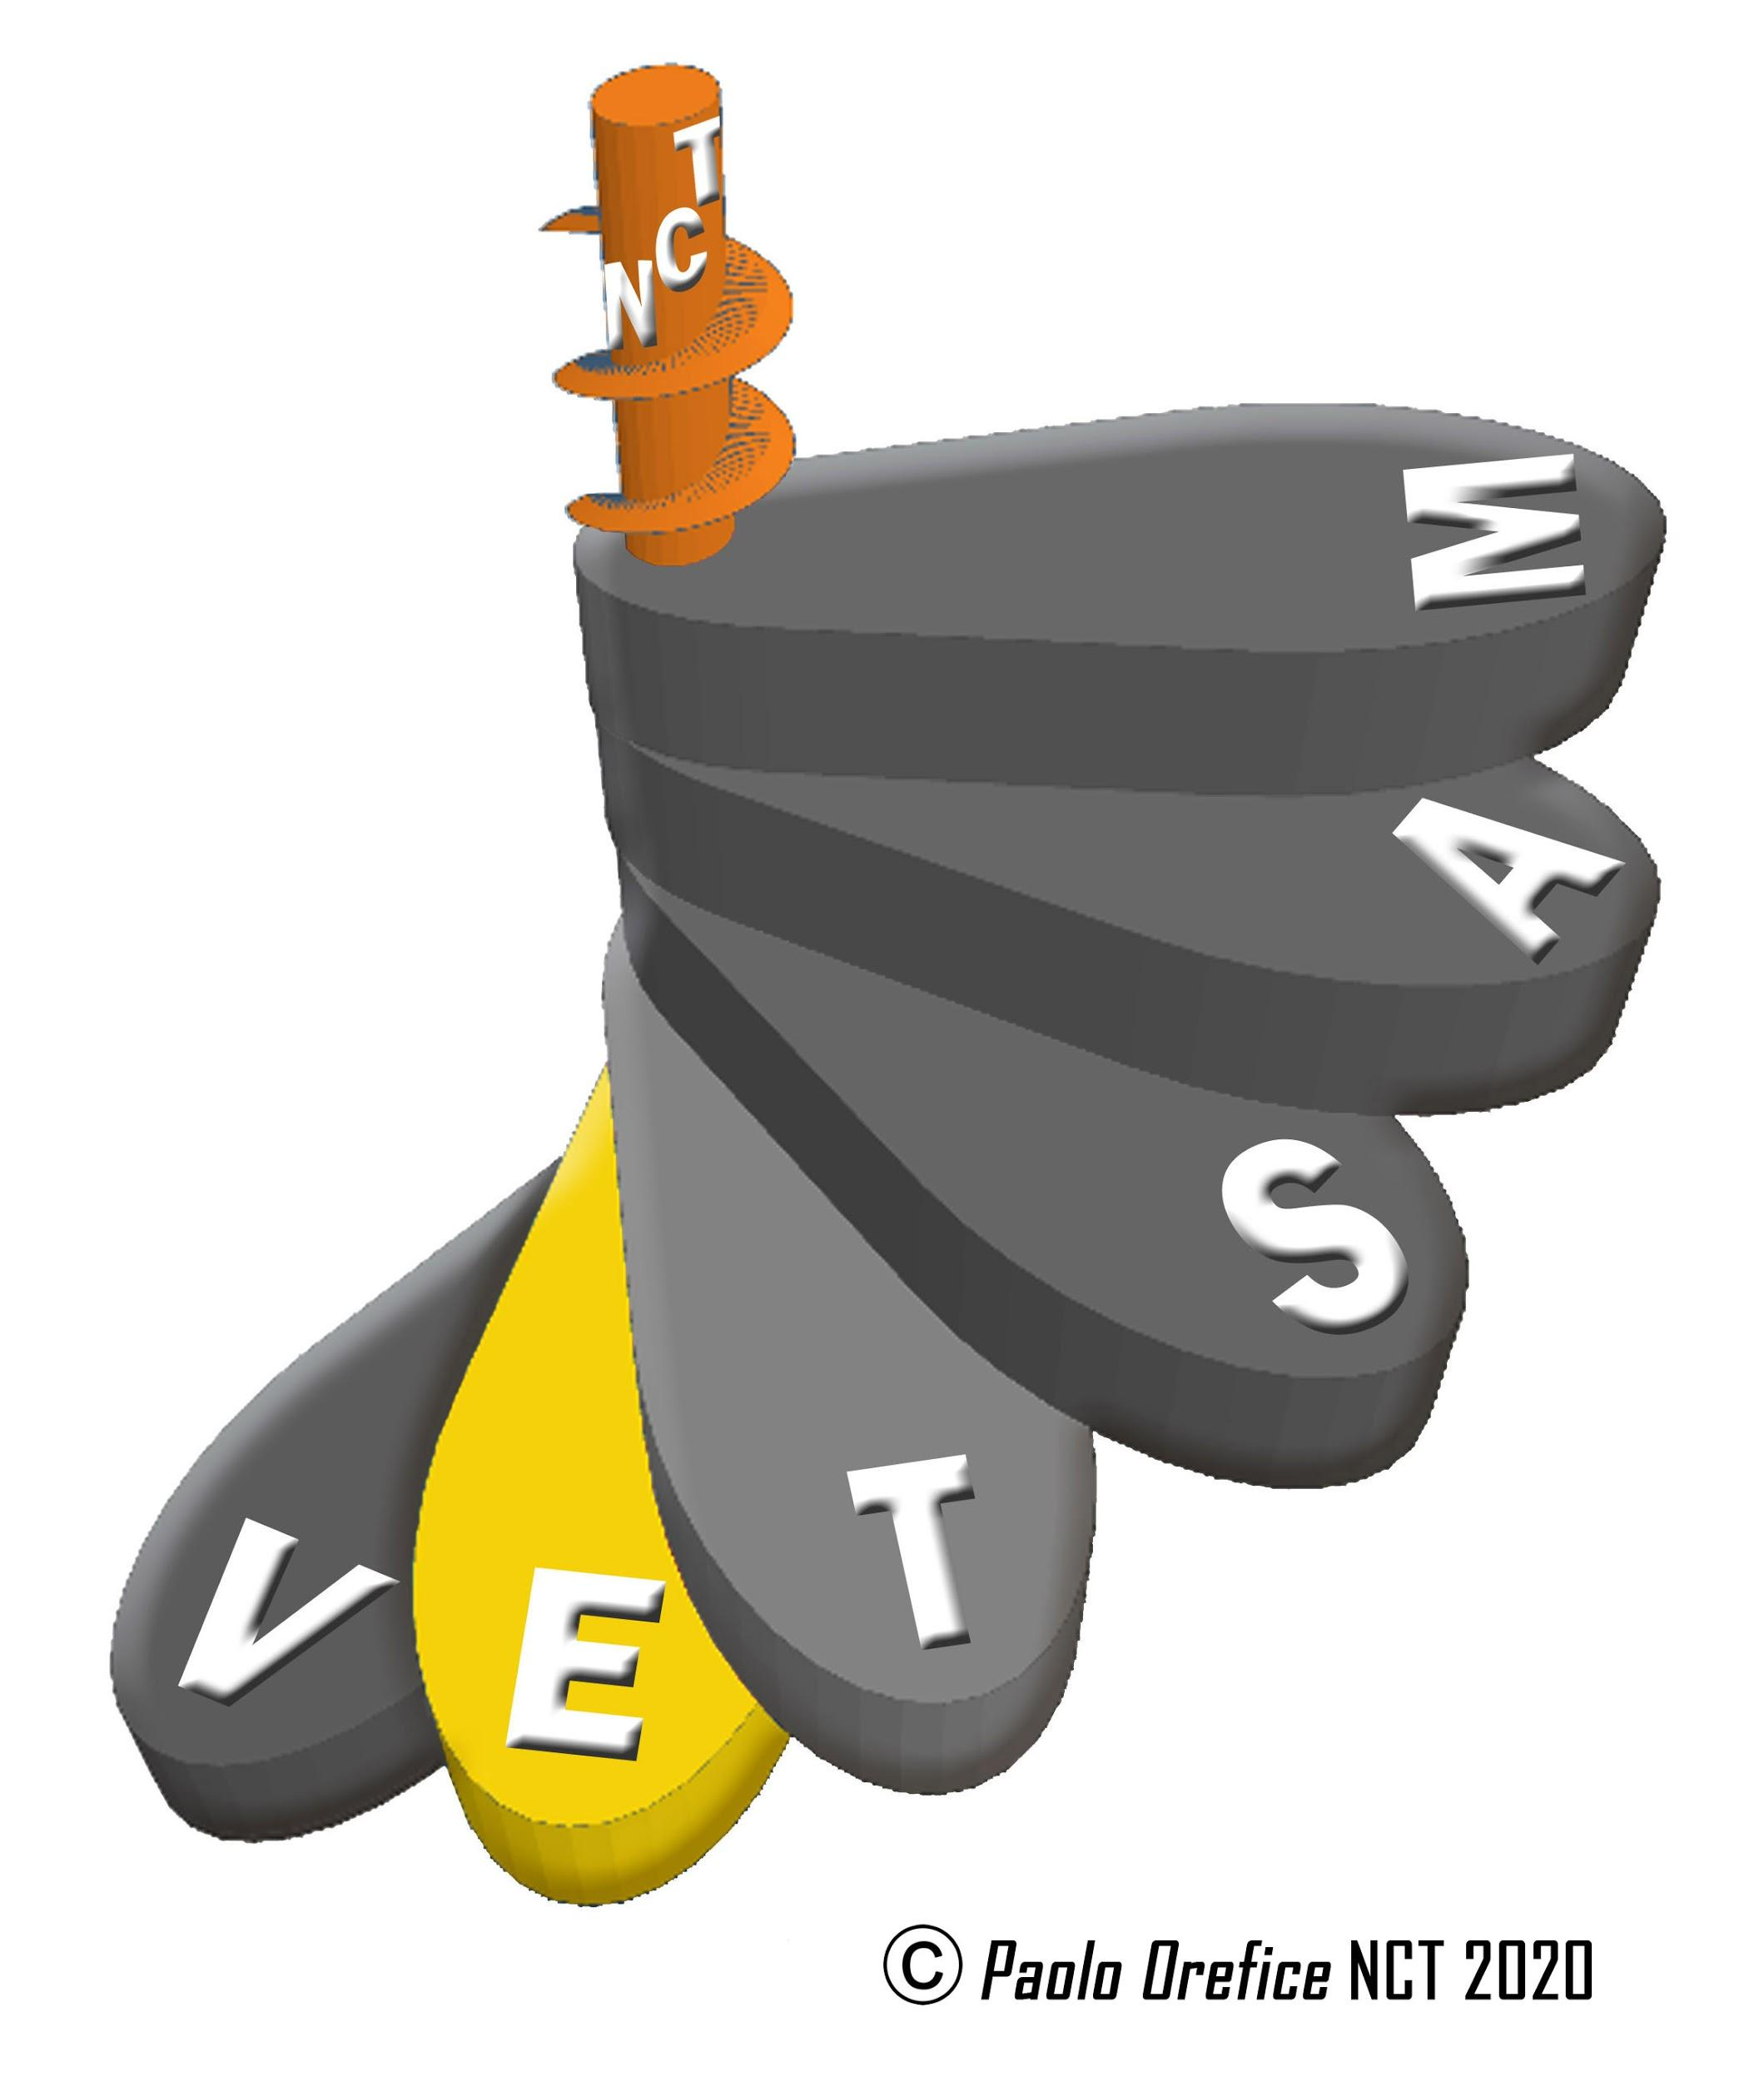
Presentation of the Week: Elisabetta Cerbai (University of Florence – Italia
Moderator: Francesco Gervasi (Autonomous University of Coahuila, Mexico)

KEYNOTE LECTURE
"TRANSDISCIPLINARY EVOLUTIONS OF REALITY:
THE CASE OF THE LIFE SCIENCES "
Josep E. Baños.
University of Vic-Central University of Catalonia, SPAIN/ CTU, Italy.

ROUND TABLE
"TRANSDISCIPLINARY SCIENTISTS: BEYOND DISCIPLINARY ANTAGONISMS"

"Odi et amo: transdisciplinarity as a privileged resource to understand today's world".
Francesco Gervasi Autonomous University of Coahuila, Mexico.

"From ecology to the humanities: the search for the meaning of the imaginary".
Juan M. Aragón P. Autonomous University of Coahuila, Mexico.

"Engineering in Social Communication and Comuniconomie. Social life and its constructive processes."
Jesús Galindo Cáceres. Engineering Group in Social Communication, Mexico.

"Interpoiesis: overcoming isolated research".
Rolando Rebolledo Berroeta. Valparaíso University, Chile.

FRIDAY, JANUARY 29, 2021

CTU, ITALY
SCIENCES FOR THE 21ST CENTURY.
OVERCOMING DISCIPLINARY ANTAGONISMS TO RE-THINK 21ST CENTURY REALITY

SYMPOSIUM
"TRANS-VIOLENCE: THE TRANSDISCIPLINARY REASONS TO OVERCOME VIOLENCE"
Moderator: Carlo Orefice, University of Siena, Italy

"The relationship between transdisciplinarity and overcoming violence: towards a new historical paradigm".
Carlo Orefice. University of Siena, Italy / UTC, University of Florence, Italy.

"IA to counteract fakes news and social media amplifiers of violence".
Jesus Miguel Flores Vivar. Founder and Director of Internet Medialab. Complutense University of Madrid, Spain.

"Social pedagogy to build resilience against hate discourse: primary prevention of radicalization to violent extremism."
Vivek Venkatesh. C. UNESCO, Concordia University, Canada.

"University education for democratic citizenship".
Ana Ma. Vega Gutiérrez. C. UNESCO, University of La Rioja, Spain.

"Multiethnic coexistence practices: the FORWARD project”.
Loretta Fabbri/Claudio Melacarne. University of Siena, Italy.

WEDNESDAY, FEBRUARY 3, 2021

CETRANS, BRASIL
TRANS = EMBODIMENT OF BEING
Moderator: Susannah Hays

KEYNOTE LECTURE
“A TRANSDISCIPLINARY THEORY OF SOCIALITY.
THE POLIVAGAL THEORY "
Stephen W. Porges
Commentator: Margarita de Vivero Zuber

ROUND TABLE
"EXPERIENTIAL PRACTICE"

"Higher Energies, Higher Foods: The Practical Reality of Spiritual Life".
Joseph Azize.
Commentator: Jack Cain

"The force of Transdisciplinary implication".
Joseph E. Brenner
Commentator: Édouard Stacke

FRIDAY, FEBRUARY 5, 2021

CETRANS, BRASIL
TRANS = EMBODIMENT OF BEING

SYMPOSIUM
THE FUTURE OF EDUCATION
Moderator: Susannah Hays

"Educational Futures: The Transdisciplinary Pedagogies of Love, Life, Wisdom and Voice".
Jennifer Gidley

"Humanology".
Harold Terry Lindahl.
Commentator: Maria F. de Mello

"The science of being: evolving beyond our natural attitude". Conversation between Stephen W. Porges, Harold T. Lindahl and Susannah Hays.

WEDNESDAY, FEBRUARY 10, 2021
INAH, MEXICO
TRANSDISCIPLINARITY AND CURRENT PROBLEMS IN MEXICAN ANTHROPOLOGY
Moderator: Arturo Lozano Cabello. INAH, Mexico.

10:00 hrs.
KEYNOTE LECTURE
“TEXTS AND CONTEXTS OF CULTURAL HERITAGE
IN MEXICO”
Aída Castilleja González. Technical Secretary. INAH, Mexico.

11:00 hrs.
ROUND TABLE
“ANTROPOLOGY:
COMPLEX AND TRANSDICIPLINARY PERSPECTIVES”
Moderator: Margarita Zárate Vidal

"Behavior: transdisciplinary phenomenon".
Xavier Lizárraga Cruchaga. INAH, Mexico.

"Between the lost paradigm and the subverted Eden: the case of Mexican physical anthropology".
José Luis Vera. ENAH, Mexico.

"The affordances as tools for cooperation and interdependence".
Melina Gastelum. UNAM, Mexico. Juan Manuel Argüelles. INAH, Mexico.

"Anthropology of violence: intra, inter and transdisciplinary perspectives".
Florence Rosemberg. ENAH, Mexico.

FRIDAY, FEBRUARY 12, 2021

INAH, MEXICO
TRANSDISCIPLINARITY AND CURRENT PROBLEMS IN MEXICAN ANTHROPOLOGY

SYMPOSIUM
"TRANSCULTURALITY IN DIFFERENT SEMIOTIC-DISCURSIVE PRACTICES"
Moderator: Olivia Fragoso Susunaga

"Graffiti Writers: Alternative Urban Transculturality".
Marco Tulio Pedroza Amarillas. ENAH, Mexico.

"The safeguarding of the intangible transcultural heritage: From complexity and transdisciplinarity".
Rafael A. Osorio Rivera. UNAM/UNITEC, Mexico.

"The Cathedral of Saltillo as a verbovisual discourse. Theoretical-methodological proposal from the complexity".
Gabriel I. Verduzco Argüelles. Autonomous University of Coahuila, Mexico.

"Posthumanism, the increase in complexity and the pain of the irreversible".
Waldir Sánchez Ortiz. ENAH, Mexico.

"Understanding utopia in science fiction: complexity and levels of reality".
Oscar Andrés Treviño Contreras. UANL, Mexico.

WEDNESDAY, FEBRUARY 24, 2021

REFICA, AFRICA
AFRICAN CULTURE

KEYNOTE LECTURE
“THE CHARACTERISTICS OF AFRICAN CULTURE”
Nouréini Tidjani-Serpos

ROUND TABLE
“TRADITIONAL AFRICAN KNOWLEDGE”
Moderator: Djénéba Traore

"Knowledge of African culture".
Migyikra Erasmus

"The contribution of African cultures to the knowledge of the world".
Roukiatou Hampate Ba

"The valorization of traditional African knowledge. A transdisciplinary point of view".
Paolo Orefice

FRIDAY, FEBRUARY 26, 2021

REFICA, AFRICA
AFRICAN CULTURE

SYMPOSIUM
“AFRICAN CULTURE, CHALLENGES AND PROSPECTS”
Moderator: João de Deus

"Africa and its diaspora"
Ana Elisa Santana Afonso

"African Women and Culture: Challenges and Perspectives"
Coumba Fall Venn

"African Culture".
Erasmus Migyikra

WEDNESDAY, MARCH 3, 2021

PUIC (UNAM), MEXICO
TRANSDISCIPLINARITY AND THE ART OF ANCESTRAL CULTURES
Moderator: Teresa Romero Tovar

KEYNOTE LECTURE
“WORLDVIEWS, ART AND INDIGENOUS PEOPLES”
Irma Pineda Santiago
Zapotec Poet, Oaxaca, ONU

ROUND TABLE
“LITERARY EXPRESSIONS FROM INDIGENOUS PEOPLES”
Moderator: Miguel Angel Rubio Jiménez

"Poetics of migration. Writing in native languages".
Nadia López García. Mixtec Poet, México.

"Indigenous Poetry in Mexico".
Juana Peñate Montejo. Ch’ol Poet, México.

"Oral and written literature in native languages of Mexico".
Gabriel Pacheco Salvador. Huichol Writer, Nayarit, México.

FRIDAY, MARCH 5, 2021
PUIC (UNAM), MEXICO
HEALTH AND MEDICINE OF ANCESTRAL CULTURES
Moderator: Carolina Sánchez García

SYMPOSIUM
“HEALTH AND TRADITIONAL MEDICINE AMONG INDIGENOUS PEOPLES”

KEYNOTE LECTURE

HEALTH AND TRADITIONAL MEDICINE AMONG INDIGENOUS PEOPLES OF MEXICO
Roberto Campos
Facultad de Medicina, UNAM- PUIC, MEXICO

Irma Sarmiento Rodriguez
Midwife Totonaca

Tirzo Jiménez Vaquero
PrayMan Totonaca

Cruz Ramirez Vega
Medicine man Totonaca

WEDNESDAY, MARCH 10, 2021

REAL WORLD MULTIVERSITY

EDGAR MORIN, MEXICO

COMPLEX THOUGHT AND TRANSDISCIPLINARITY. EDUCATIONAL EXPERIENCES

KEYNOTE LECTURE
“COMPLEX THINKING, TRANSDISCIPLINARITY AND UNIVERSITY EDUCATION”
Virginia Gonfiantini Benassi

ROUND TABLE
“INVESTIGATING FROM COMPLEX THINKING AND TRANSDISCIPLINARITY”
Moderator: Virginia Gonfiantini Benassi

"Borders and paradigm changes in the 21st Century".
Roberto Rivera Pérez

"The anthropoetics of Edgar Morin and its concretion in the 21st Century university".
Jorge Colorado Lanestosa

"Preliminary and basic guidelines for investigating from complex thinking and transdisciplinarity".
José Gustavo Casas Álvarez

FRIDAY, MARCH 12, 2021

REAL WORLD MULTIVERSITY EDGAR MORIN, MEXICO

COMPLEX THOUGHT AND TRANSDISCIPLINARITY. EDUCATIONAL EXPERIENCES

SYMPOSIUM
“RESEARCH AND ACTION WITH A COMPLEX AND TRANSDISCIPLINARY ORIENTATION”
Moderators: Gustavo Casas Álvarez / Roberto Rivera Pérez

"Vital school and complexity in ‘Escuela Normal Superior’".
Ovic Lucía Tabares Jaramillo

"Training in palliative care and transdisciplinarity".
Luz Marina Cano Molano

"Education for complex understanding in universities".
Adriane Lorenzon Dos Santos

"Sexual and gender identities: multidimensional complexity and educational settings".
Norma Jurado Campusano

WEDNESDAY, MARCH 17, 2021

ENAH, MEXICO
THE PATHS OF TRANSDISCIPLINARITY IN CULTURAL ANALYSIS
Moderator: Karla Vivar Quiroz

KEYNOTE LECTURE
“TRANSDISCIPLINARITY AS AN EPISTEMOLOGICAL ATTITUDE FOR UNDERSTANDING THE HUMAN BEING”
Hilario Topete Lara
Director ENAH, Mexico

ROUND TABLE
"COMPLEXLY VIRAL: MULTI / TRANS / INTERDISCIPLINARY REFLECTIONS ON THE PANDEMIC"

"The museum of the pandemic: things, materials and flows of a new daily life".
Blanca María Cárdenas Carrión. UNAM, Mexico.

"Indigenous people, mestizos and COVID-19: cosmopolitical responses to the pandemic".
Carlos Arturo Hernández Dávila ENAH, MEXICO

"Anthropological production and creative horizons".
Pedro Ovando Vázquez. CNA, INAH, Mexico.

FRIDAY, MARCH 19, 2021

ENAH, MEXICO
"THE PATHS OF TRANSDISCIPLINARITY IN CULTURAL ANALYSIS
Moderator: José Juan Zamora Pardo. ENAH, Mexico.

SYMPOSIUM
"TRANSDISCIPLINARITY, INTERDISCIPLINARITY AND COMPLEXITY IN THE WORK OF THE WORD ARCHIVE"

"The theses of complexity in the work of the Word Archive".
Vladimir Mompeller Prado. Word Archive. ENAH, Mexico.

“The complexity of the ethnographic process in the registration of intangible cultural heritage”.
Montserrat Patricia Rebollo Cruz. Word Archive. ENAH, Mexico.

“The archiving of a word and archivonomy. A link beyond the technical organization”.
Silvia Guillermina García Santiago

"The audiovisual ethnographic record as a complex act."
Jorge Octavio Hernández Espejo. Word Archive. ENAH, Mexico.

“The Immaterial on the screen. The documentaries of the Archiving of a Word as an interdisciplinary exercise between anthropology and cinema”.
Rafael Torres Rodríguez. Word Archive. ENAH, Mexico.

WEDNESDAY, MARCH 24, 2021
CTU, ITALY
SPECIES RELATIONAL INTELLIGENCE FOR THE 21ST CENTURY
Week III. Transdisciplinary Theory
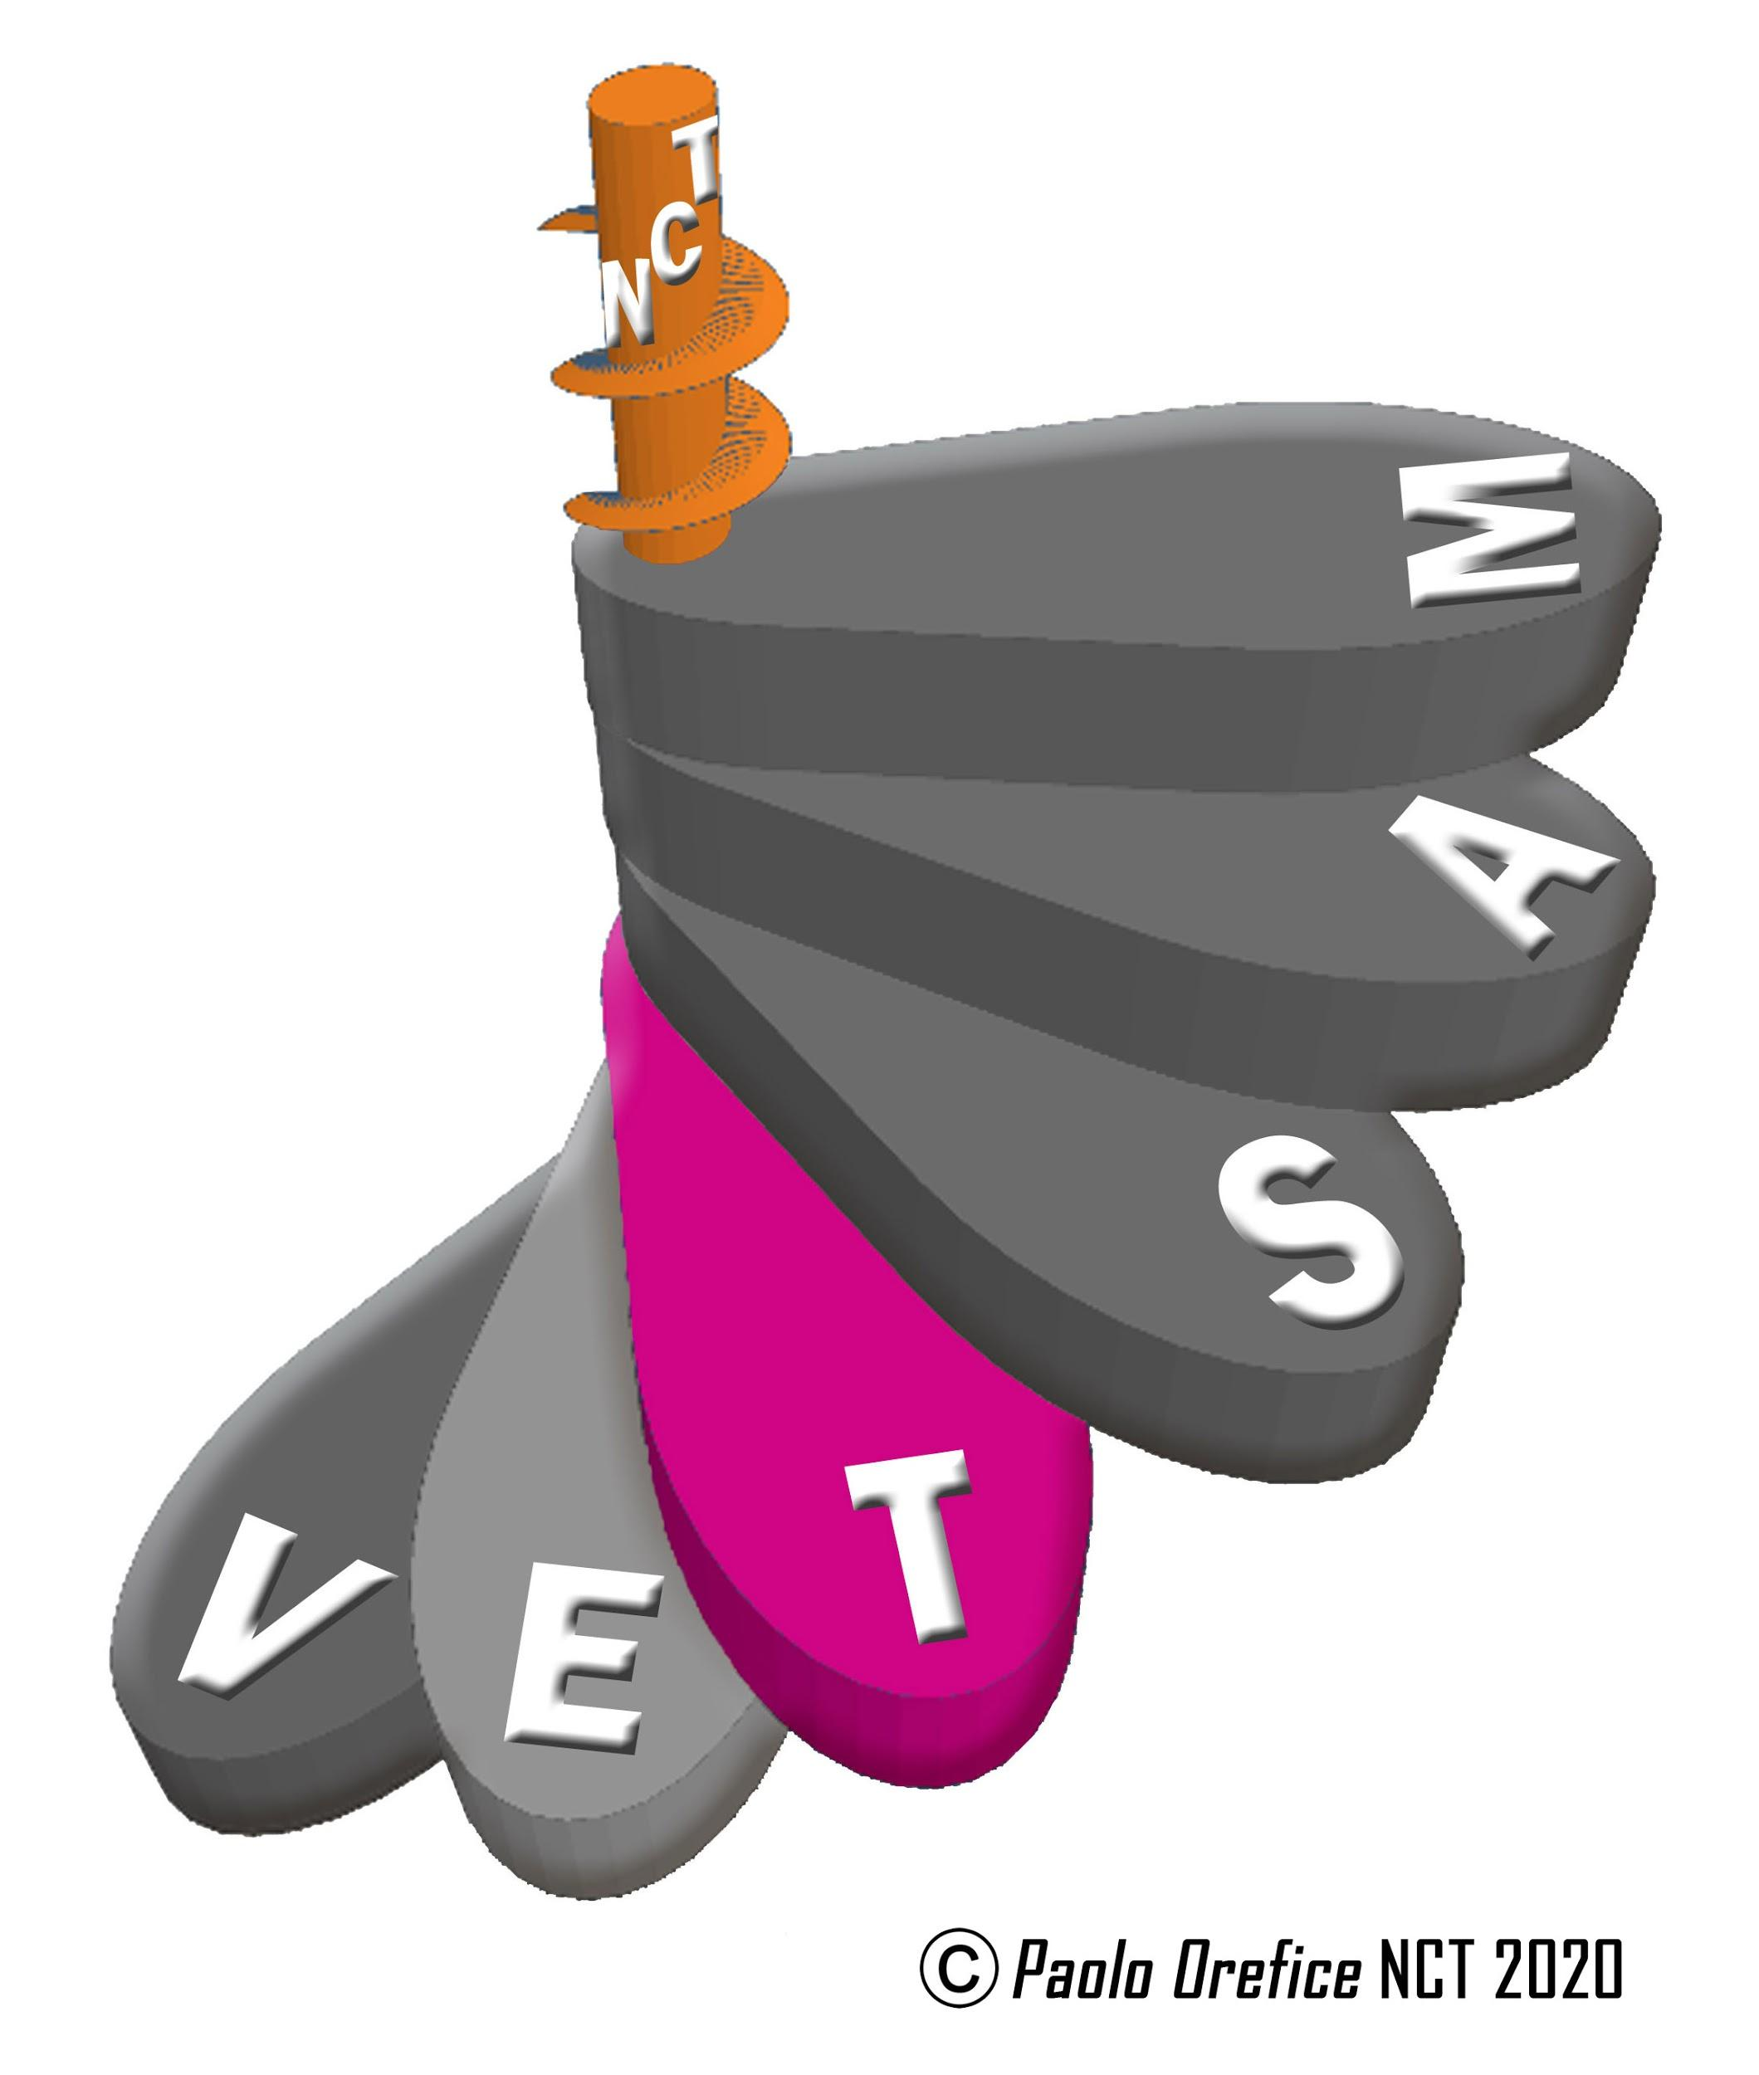
Presentation of the week: Laura Solito. Pro Rector, University of Florence, Italy. Moderator: Alberto Garcia UNESCO Chair, Pontifical A. Regina Apostolorum, Italy.

KEYNOTE LECTURE
“THE CHALLENGE OF RELATIONAL INTELLIGENCE FOR A SUSTAINABLE CIVILIZATION. TRANSDISCIPLINARY LOOK AT THE KNOWLEDGE OF THE LIVING "
Paolo Orefice.
CTU/ University of Florence, Italy.
ROUND TABLE
“EVOLUTION OF LIFE AND KNOWLEDGE IN THE BIOSPHERE”
Moderator: Alberto Garcia

"Bioethical challenges of artificial intelligence for sustainable development respectful of human rights".
Alberto García. UNESCO Chair, Pontifical Athenaeum Regina Apostolorum, Italy.

"Cognitive behaviors in plants".
Miguel Segundo-Ortina. University of Utrecht, Netherlands.

"The interface plant-environment: a mesological approach to plant cognition".
Marc Williams Debono.

"Ancestral memory and transdisciplinary records of the Cura Landscapes".
Adine Gavazzi. UNESCO Chair, University of Genova, Italy.

"Human intelligence and bioethics through cinema".
Irene Cambra Badii. University of Vic, Central University of Catalonia, Spain.

FRIDAY, MARCH 26, 2021

CTU, ITALY
SPECIES RELATIONAL INTELLIGENCE FOR THE 21ST CENTURY
Week III. Transdisciplinary Theory
SYMPOSIUM
"THE RELATIONSHIPS BETWEEN INTELLIGENCES"
Introduction to the topic / Moderator: Marco Fioravanti Marco UTC Chair University of Florence, Italy

"How much stability does it take to be able to move freely in thought and creativity? ".
Anna Ferruta. Italian Psychoanalytic Society, Italy.

"Steps to understand the behavior of plants".
Vicente Raja Galian. Minimal Intelligence Lab/University of Murcia, Spain.

"Health / Illness: a path in transdisciplinarity".
Antonio Guerci. UNESCO Chair, University of Genova, Italy.

Symbolic construction and mathematical codes in Mayan culture
Fidencio Briceño Ch’el, National Institute of Anthropology and History, Yucatan, Mexico.

WEDNESDAY, APRIL 7, 2021

CETRANS, BRASIL
TRANSDISCIPLINARITY in VIVO
Moderator: Maria Fernandez de Mello

KEYNOTE LECTURE
THE INTRA-TRANSDISCIPLINARY REJUNCTION
Joseph Brenner

ROUND TABLE
“FROM TRANSDISCIPLINARY PRINCIPLES TO PRACTICE”

"Holistic Transdisciplinarity: Experiences and Challenges in Virtual Learning Environments".
Nelma Sá.

"Transdisciplinarity and Life Purpose with Health and Well-Being in Maturity".
Fernando Bignardi.

The beautiful as liberation crack in the prison environment.
Ideli Domingues.

FRIDAY APRIL 9, 2021

CETRANS, BRASIL
TRANSDISCIPLINARITY in VIVO
Moderator: Maria Fernandez de Mello

SYMPOSIUM
“PSYVOLUTION IN THE TRANSDISCIPLINARY PATH”

"Transdisciplinary Encounter: A Transformational Path".
Roberto Crema.

"Transdisciplinarity and Intergeracional Relation in Auto-cognium Processes".
Denise Lagrotta.

"Journalism, Periphery and Language Questions in Transdisciplinary Knowledge".
Vicente L. de Goes.

Being in the World and the unveiling of Being
Vitoria M de Barros.

WEDNESDAY, APRIL 14, 2021
CIRET, FRANCE
TRANSDISCIPLINARY ASPECTS OF LITERATURE
Coordinator and moderator: Bénédicte Letellier
KEY NOTE LECTURE
“THE CURRENT ISSUES OF TRANSDISCIPLINARITY IN LITERATURE”
Bénédicte Letellier, Poet and Translator
Reunion University, France.
KEY NOTE LECTURE
“DIALOGUE ON POETRY AND SCIENCE”
Bénédicte Letellier, France.
ROUND TABLE
“TRANSDISCIPLINARY ASPECTS OF LITERATURE”

"A Fractal Literature".
Simona Modreanu. University Alexandru Ioan Cuza de Iași, Rumania

"Towards a transdisciplinary anarchism".
Alain Santacreu. Founder of the Counter-literature Journal.

"On transpoetry".
Magda Carneci. Poet, essayist and art historian.

« Transtextuality »
Marc-Williams Debono
(Researcher and founder of the Transdisciplinary journal PLASTIR)

FRIDAY, 16 APRIL, 2021

CIRET, FRANCE
TRANSDISCIPLINARY ASPECTS OF LITERATURE
Coordinator and moderator: Bénédicte Letellier

SYMPOSIUM
“TRANSDISCIPLINARY ASPECTS OF LITERATURE”

KEYNOTE LECTURE
"WORD, NUMBER, WRITING".
Clara Janès. Poet, translator and writer.

"Portuguese variants of Faust"
José Oliveira. University of Evora, Portugal.

"Appeal to a new Artistic Physics".
Hélène Fau. Sarrebruck University, Germany.

"Transdisciplinary Literature: the novel as artistic research".
Susan Rowland. Pacifica Graduate Institute, USA.

"The Fall of Literary Theory: A 21st Century Return to Poststructuralism and Deconstruction".
Liana V. Andreasen South Texas College, USA.

WEDNESDAY, APRIL 21, 2021

IISUE (UNAM/UNESCO), MEXICO
THE CHALLENGES OF TRANSDISCIPLINARITY IN THE LATIN AMERICAN UNIVERSITY
Moderator: Rafael Lara Barragán
Director del Centro de Estudios Superiores en Educación-CESE, México
KEYNOTE LECTURE
"THE DEBATE ON TRANSDISCIPLINARITY AT THE
LATIN AMERICA UNIVERSITY"
Axel Didriksson. Coordinator of the UNESCO CHAIR University and Regional Integration, UNAM, Mexico.
ROUND TABLE
THE CHALLENGES OF TRANSDISCIPLINARITY IN THE LATIN AMERICAN UNIVERSITY

COMMENTATORS:
Carmen Caamaño.
Social Research Institute, University of Costa Rica

Damián del Valle.
National University of Arts, Argentina

María Magdalena Sarraute.
Faculty of Higher Studies, UNAM, Mexico

Célia Caregnato.
Federal University of Rio Grande do Sul (UFRGDS), Brazil

FRIDAY 23 APRIL 2021

IISUE (UNAM/UNESCO), MEXICO
TRANSDISCIPLINARITY CHALLENGES IN A LATIN AMERICAN UNIVERSITY

SYMPOSIUM
"THE SYNERGY OF HUMANITIES, ART, SCIENCE AND TECHNOLOGY IN A LATIN AMERICAN UNIVERSITY"
Moderator: Axel Didriksson ,UNAM, Mexico
IISUE-UNAM. UNESCO CHAIR, University and Regional Integration
UNAM, Mexico

The digital transformation of the University in the context of the pandemic
Francesc Pedró. IESALC/UNESCO
Director of the UNESCO International Institute for Higher Education in Latin America and the Caribbean (IIESALC-UNESCO).
The Arts and Transdisciplinarity
Sandra Torlucci.
Rector of the National University of Arts (UNA), Argentina.
Body, Education and Transdisciplinarity
Freddy Álvarez.
Ex-rector of the National University of Education UNAE). Ecuador.
University Integration and Transdisciplinarity
Gustavo Oliveira.
Ex-Rector of the University for Regional Integration (UNILA). Brazil

WEDNESDAY, APRIL 28, 2021
C3, UNAM, UAM-XOCHIMILCO, MEXICO
ART AND SCIENCES OF COMPLEXITY
Moderator: Antonio del Rivero Herrera. UAM, Mexico

KEYNOTE LECTURE
“EMERGING PROPERTIES: ART, BIOCOMPLEXITY AND SOCIETY”
Manolo Cocho. C3-UNAM, Mexico.

ROUND TABLE
“ART AS A TRANSDISCIPLINARY ARTIFACT. CROSSES BETWEEN ART AND SCIENCE IN THE EXHIBITION TRANSMUTATION. ALCHEMIES FROM SPACE”
Moderator: Antonio del Rivero Herrera. UAM, Mexico.
Tania Aedo, Paloma Oliveira, Jaime Lobato. UNAM, Mexico.
Summary: Contemporary art has turned its gaze for several years to the cross between art and science. But it is not the work of art itself that contains all the strategies of communication with the public, it is within the museum machinery that strategies are developed they help concepts to have their own life between the audience. This table will discuss the experiences of three central actors in the montage of the Transmutation exhibition. Alchemies from Space. Launched at the Art Alameda Laboratory in 2017.

,.

FRIDAY, APRIL 30, 2021

C3, UNAM, UAM-XOCHIMILCO,MEXICO
ART AND SCIENCES OF COMPLEXITY
Moderator: Antonio del Rivero Herrera. UAM, Mexico.

SYMPOSIUM
“MUSIC TECHNOLOGY IN TRANSDISCIPLINARITY: A DISRUPTIVE / COLLABORATIVE APPROACH IN THE CREATION OF TRANSMEDIA CONTENT”

COLLECTIVE PRESENTATION: CORPORALITY AND MUSICAL TECHNOLOGY: A TRANSDISCIPLINARY APPROACH

Jesús Gómez. FaM-UNAM, Mexico.
Enrique Flores. FaM-UNAM, Mexico.
Rossana Lara. FaM-UNAM, Mexico.
Fabian Ávila UNAM, SECRETARIA DE CULTURA, Mexico

WEDNESDAY, MAY 5, 2021

REFICA, AFRICA
INTERRELIGIOUS DIALOGUE

KEYNOTE LECTURE
INTERRELIGIOUS DIALOGUE, AFRICA'S CONTRIBUTION
Mathias Savadogo

ROUND TABLE
“IS INTERRELIGIOUS DIALOGUE POSSIBLE?”
Moderator: Djénéba TRAORE

Interreligious dialogue Africa
Eugène Goussikindey

Interreligious dialogue for terrestrial civilization: transdisciplinary problems and paths
Paolo Orefice UNESCO Transdisciplinary Chair- University of Florence

FRIDAY, MAY 7, 2021

REFICA, AFRICA
INTERRELIGIOUS DIALOGUE

SYMPOSIUM
“INTERRELIGIOUS DIALOGUE, OBJECTIVES AND CHALLENGES”
Moderator: Eugène Goussikindey

Objectives and challenges of interreligious dialogue
Denise Houphouët-Boigny, Africa

Interreligious dialogue, objectives and challenges
Mathias Savadogo. Africa World Institute, Africa.

WEDNESDAY, MAY 12, 2021
CIRET, FRANCE
RELATION BETWEEN TRANSGENERATIONAL AND TRANSDISCIPLINARITY
Coordinator y moderator: Patrik Standar

WORDS OF WELCOME AND INTRODUCTION
Florent Pasquier. CIRET, France.

KEY NOTE LECTURE
“FROM INTER TO TRANS: GOING BETWEEN TO GO BEYOND. TRANSDISCIPLINARITY, WHAT HAS INTERGENERATIONAL WORK TO DO WITH IT”
Peter Whitehouse
Case Western Reserve University, USA. Toronto University, Canada.

ROUND TABLE
“INTER HUB: AN ONLINE PROCESS OF DEEP INTERGENERATIONAL AND DIALOGUE TO TRANSFORM SOCIETY”

Peter Whitehouse. Case Western Reserve University, USA, Toronto University, Canada.

Estelle Archibold. Case Western Reserve University, USA.

Patrik Estándar. Linnaeus University, Sweden.

Richard Geer. StoryBridge (CPI).

FRIDAY, MAY 14, 2021
CIRET, FRANCE
RELATION BETWEEN TRANSGENERATIONAL AND TRANSDISCIPLINARITY
Moderator: Peter Whitehouse

SYMPOSIUM
“THE TRANSDISCIPLINARY INTERGENERATIONAL UNIVERSITY OF THE FUTURE”
Introduction and welcome: Florent Pasquier

Peter Whitehouse. Case Western Reserve University, USA, Toronto University, Canada.

Mark Turner. Universidad Case Western Reserve, EUA.
Jonathan Beever. Universidad de Florida Central, EUA.
R. Mariano Sánchez, Universidad de Granada España.
Matthew Kaplan. Colegio de Ciencias Agrícolas, Penn State, EUA.

Rick Moody
Rick Lathrop
Maria Genne
Parker Genné
Paul Leslie
Jerry EDWARD Gale
Herman Greene
David Blake Willis

WEDNESDAY, MAY 19, 2021

REDES, AFRICA
EDUCATION AND ECOLOGICAL TRANSITION
Moderator: Paolo Orefice, UTC, University of Florence

KEYNOTE LECTURE
“METHODOLOGY FOR AN EDUCATION IN ECOLOGICAL TRANSITION”
Abdoulaye Konté

ROUND TABLE
"SHARING OF EXPERIENCES"
Lycée Bambey Sérére, Lycée de Gascop
Moderator: Saliou Sakho

"The pedagogical interest of introducing ecology into the Lyceum."
Elhadji NIANE. Agronomist Engineer

The challenge of introducing ecology in secondary school (ECOLYCO Project)
Ibou Ngom. Bambey Sérére High School.

FRIDAY, MAY 21, 2021

REDES, AFRICA
EDUCATION AND ECOLOGICAL TRANSITION

SYMPOSIUM
“EDUCATION FOR ECOLOGICAL TRANSITION PARTNERSHIP”
Moderator: Ibou Ngom
Coordinador de proyectos de ecología en escuelas secundarias y colegios ECOLYCO

Education for the ecological transition outside the school
Saliou Sakho. Professor, researcher
From the classroom to the garden: Actions that transform the school and the student
Diafara Diallo. Professor of Life and Earth Science.

Education for ecological transition. Place and roles of territorial
communities.
Pape Daouda Gaye - Teacher-Municipal Secretary

WEDNESDAY, MAY 26, 2021
CTU, ITALY
PROFESSIONALITIES AND SUSTAINABLE SYSTEMS.
FOR A TRANSDISCIPLINARY ETHICS OF HUMAN NETWORKS AND COMMUNITY WORK
Week IV. Transdisciplinary Apparatus
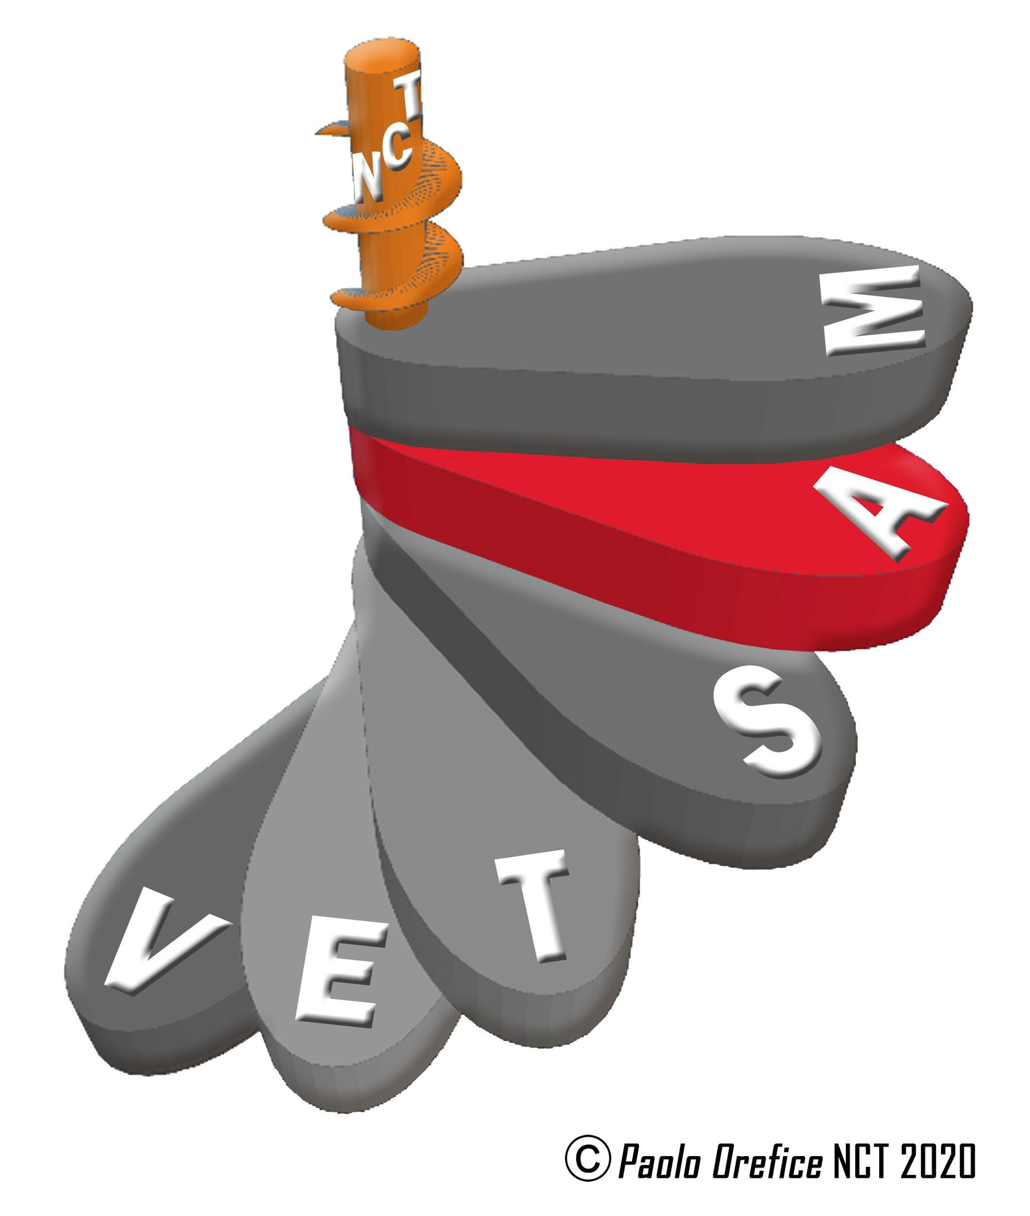
Presentation of Week: Saverio Mecca. University of Florence, Italy.
Moderator: Francesco Castelli. UNESCO Chair, University of Brescia, Italy.

KEYNOTE LECTURE
"OVERCOMING A SIMPLIFIED NETWORK CULTURE:
NEWS IN PROFESSIONS AND ORGANIZATIONS"
Esteban Sefair Vera. Valparaíso University, Chile.

ROUND TABLE
"ACTIONS AND INTERCONNECTIONS FOR SUSTAINABLE DEVELOPMENT"
Moderator: Francesco Castelli.

"Sustainability and transdisciplinarity".
Francesco Castelli. UNESCO Chair, University of Brescia, Italy.

"The enduring promise. Translating epistemologies, reassembling facts and values".
Dario Minervini (University of Naples "Federico II")

"Prevention and sustainable management of hydrogeological risk"
Nicola Casagli. UNESCO Chair, University of Florence, Italy.

FRIDAY, MAY 28, 2021
CTU, ITALY
PROFESSIONALITIES AND SUSTAINABLE SYSTEMS.
FOR A TRANSDISCIPLINARY ETHICS OF HUMAN NETWORKS AND COMMUNITY WORK

SYMPOSIUM
"CONNECTIONS AND SOCIABILITY:
THE COVID-19 EXPERIENCE"
Moderator: Francesca Bianchi
"Interactions, social networks, spaces: What challenges for the pandemic change?".
Francesca Bianchi. University of Siena / UTC Chair University of Florence, Italy.

"Online environments, accessibility and digital interconnections. Educational paths in Covid time".
Mario Giampaolo/Alessandra Romano. Siena University, Italy.

"Participate, cooperate, share: the habitat challenges of tomorrow? French perspectives".
Sabrina Bresson. Paris University, Nanterre, France.

Sociability and culture of peace: the pandemic in Africa".
Mèkè Meite. UNESCO C., Félix Houphouët-Boigny University, Ivory Coast.

"Health and sociability: the Covid experience in Peru".
Kelly Myriam Jiménez de Aliaga. César Vallejo University, Peru.

"

WEDNESDAY, JUNE 2, 2021

CETRANS, BRASIL
COMPLEXITY AND HUMANISM
Moderator: Vitoria M. de Barros

KEYNOTE LECTURE
THE DIS-AFFIRMATION OF SELF (OF THE HUMAN BEING)
Sérgio Bolliger. Architect and Master in Philosophy

ROUND TABLE
DIS-HUMANIZATION AND DE-HUMANIZATION

“Religion in its Multi-referential and Multi-dimensional Dynamics”
Maria F. de Mello, Linguist and Educator. CETRANS/Brazil
"The Group as the Foundation of a New Humanity". Marina Bernardi, Transpersonal Psychologist. Comunità di Etica Viventi/Italy
"The emotional unconscious: a dive into infinity".
Ignácio Gerber, Musician and Psychoanalyst. CETRANS/Brazil

FRIDAY, JUNE 4, 2021
CETRANS, BRASIL
COMPLEXITY AND HUMANISM
SYMPOSIUM
COMPLEXITY AND INTERCULTURAL DIALOGUES
Opening: Estevam Barbosa Las Casas
Director of the Institute for Advanced Transdisciplinary Studies IEAT of the Federal University of Minas Gerais - UFMG.
MOMENT 1: "COMPLEXITY AND INTERCULTURAL DIALOGUES"
Moderator: Alcides Volpato Carneiro de Castro e Silva
KEY NOTE LECTURE
Katemari da Rosa
Physics and Teacher in Teaching, Philosophy and History of Sciences
Doctor in Scientific Education, Columbia University.
MOMENT 2: INTERCULTURAL DIALOGUES
MODERATOR: Maria Fernanda Salcedo Repolês
• Rosangela Pereira de Tugny. PhD in music and musicology. Research of the songs of indigenous peoples and the biographies and books of teachers of traditional communities.
• José Jorge de Carvalho: Master in Social Anthropology and Ethnomusicology. Afro-Brazilian Studies, Popular Cultures and Affirmative Actions for Blacks and Original Peoples.
• Cacique Babau Tupinambá: Brazilian indigenous leader of the Tupinambás tribe
• César Geraldo Guimarães: Doctor in Literary Studies. Comparative Literature. Coordinator of the Transversal Training in Traditional Knowledge of the Federal University of Minas Gerais - UFMG.

WEDNESDAY, JUNE 9, 2021

REFICA, AFRICA
AFRICA AND THE CORONAVIRUS PANDEMIC:
A SCIENTIFIC AND CULTURAL APPROACH

KEYNOTE LECTURE
" AFRICA AND THE CORONAVIRUS PANDEMIC:
A CULTURAL APPROACH"
Mèkè Meite

ROUND TABLE
"AFRICA AND THE CORONAVIRUS PANDEMIC:
A SCIENTIFIC APPROACH"
Moderator: Constant Roux

Africa and the Coronavirus pandemic: a scientific approach
Guillaume Yao Loukou

FRIDAY JUNE 11, 2021

REFICA, AFRICA
AFRICA AND THE CORONAVIRUS PANDEMIC:
A SCIENTIFIC AND CULTURAL APPROACH

SYMPOSIUM
"THE AFRICA POST COVID-19"
Moderator: Denise HOUPHOUËT-BOIGNY
Africa after the coronavirus pandemic. From duel to relaunch: A transdisciplinary perspective.
Paolo Orefice, CTU University of Florence, Italy
Africa and the CoronaVirus pandemic: scientific and cultural approach
Daniel Youzan Baha Bi
Africa after Covid : sociability and culture of peace
Mèkè Meite

WEDNESDAY, JUNE 16, 2021

REDES, AFRICA
VALUATION OF TRADITIONAL KNOWLEDGE
Coordinator: Abdoulaye Konte
Moderator: Saliou SAKHO

ROUND TABLE
“ TRADITIONAL KNOWLEDGE AND COMMUNITY RESILIENCE”

Traditional knowledge interests in an ever-changing world
Ndeye Oumou Khairy
"Place of traditional knowledge in pedagogical approaches.
Pape Gana Diouf
The Wolof Forge: itinerary, dynamics of reconversion and proposal of search for patrimonialization
Alasanne Fall

FRIDAY JUNE 18, 2021

REDES, AFRICA
VALUATION OF TRADITIONAL KNOWLEDGE

SYMPOSIUM
“WHAT STRATEGY TO PROMOTE TRADITIONAL KNOWLEDGE”
Coordinator: Abdoulaye Konte
Moderator: Saliou SAKHO

"The traditional knowledge of the Mapuche people".
Maria Quiñelen Martinez. Mapuche, Female Medicine, Chile.
"Expression and preservation of traditional knowledge".
Moustapha CASSET

"Place of traditional knowledge in the conservation of the African historical heritage".
Youssou Mboup.

Place of traditional knowledge in the teaching of Letters.
Elhadji Coumba Diou Seck

WEDNESDAY, JUNE 23, 2021
ANCESTRAL CULTURES, LATIN AMERICA
ANCESTRAL CULTURES IN TRANSDISCIPLINARITY, IN THE ANDES
Coordinator: Ileana Almeida, Central University of Ecuador
Coordinator and Moderator: Marisol Cárdenas Oñate.
ENAH (Mexico), Ecuador.
KEY NOTE LECTURE
"ANDEAN COSMOVIVENCE IN THE FACE OF CIVILIZING CHAOS".
Yaku Pérez Guartambel
Water Defender, Former – President of the Andean Coordinator of Indigenous Organizations, Ecuador
KEYNOTE LECTURE
“REGENERATION OF THE AYLLU MONADA. AN ANDEAN SEARCH FOR THE ANTI-SPHERE "
Jorge Sainz Cardona
San Andrés Mayor University, Bolivia.

ROUND TABLE
“ANCESTRAL CULTURES IN TRANSDISCIPLINARITY, IN LATIN AMERICA”

"Myths of origin in contemporary Quechuas".
Carmen Escalante. San Antonio Abad University Cusco, Peru.

"Heart feeling from the insurgent spiritualities and wisdoms of Abya Yala."
Patricio Guerrero. Salesiana University / Pueblo Kitu kara, Ecuador.

“Inagekey mapunche rakizuam? Kimün construction in Mapuche knowledge”.
Desiderio Catriquir Colipan. Catholic University of Temuco, Chile.

FRIDAY JUNE 25, 2021
ANCESTRAL CULTURES, LATIN AMERICA
ANCESTRAL CULTURES IN TRANSDISCIPLINARITY, IN THE ANDES
Moderator: Juan Illicachi.
National University of Chimborazo, Ecuador.
KEY NOTE LECTURE
"DIFFERENTIATION OF CIVILIZATIONAL HORIZONS AND PARADIGM OF LIFE SYSTEMS, IN THE FACE OF CLIMATE CHANGE"
Simón Yampara National University of El Alto, Bolivia
KEY NOTE LECTURE
THE AGROECOLOGICAL CYCLE AND THE LIFE CYCLE IN THE INTEGRATED TEACHING OF THE SCIENCES".
Luis Montaluisa. Salesian University, Ecuador.

SYMPOSIUM
"TRANSDISCIPLINARY INVESTIGATIONS OF ANCESTRAL PEOPLES"

The Kuarim Potø Index of a shared culture?
Ileana Almeida. Central University of Ecuador. Professor Emeritus.

"Napimmia, the rite of the snake as a spiritual pedagogy of the Shuar nationality".
Lauro Saant and Yamanua María Juank. National University of Education, Bosco Wisuna Educational Unit

“Epistemologies of diversity. Contributions from Amazonian and Andean languages”.
Ruth Moya Torres. National Academy of History, Ecuador.

WEDNESDAY, JUNE 30, 2021
CTU, ITALY
"EDUCATION, SCIENCE AND CULTURE FOR THE SUSTAINABLE DEVELOPMENT GOALS, IN THE EMERGENCY OF THE COVID-19 PANDEMIC.
Week V. Trandisciplinary Strategies
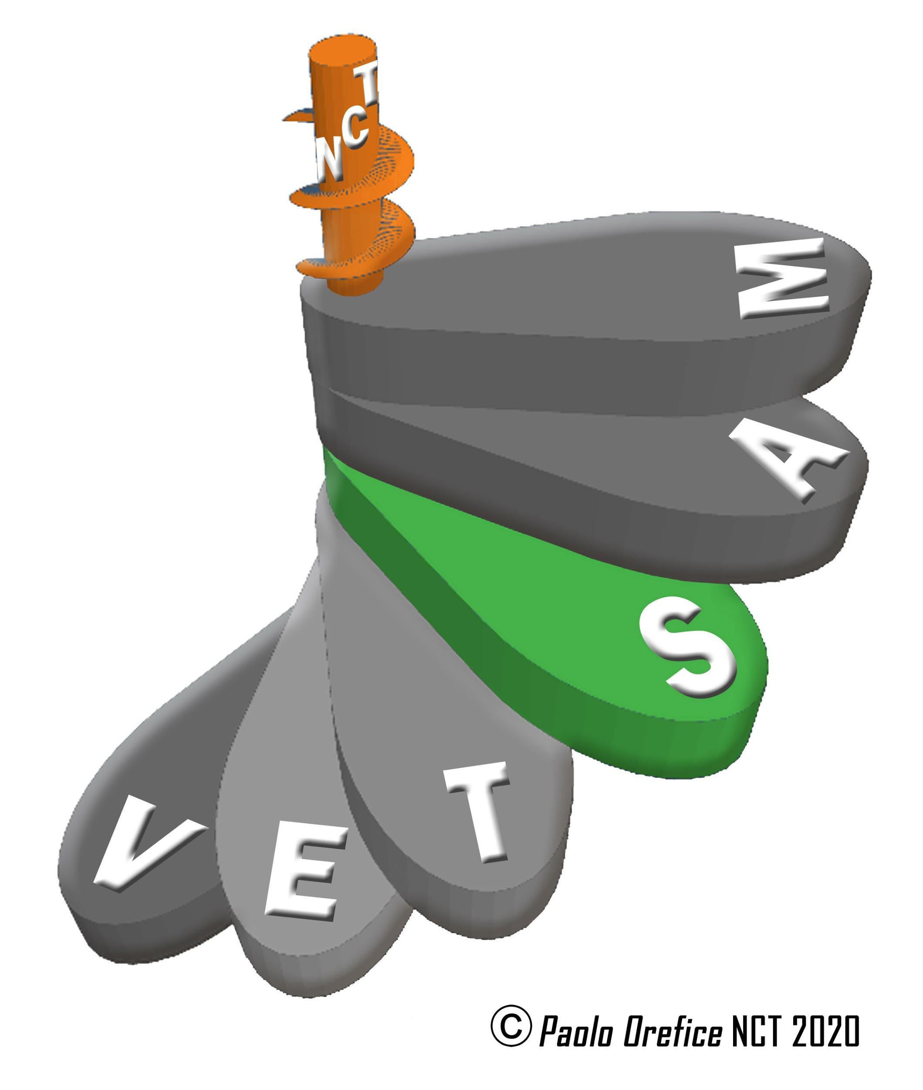
INTRODUCTION
Anna Thompson Flores. Director of the UNESCO Regional Office for Education, Science and Culture in Europe.
Enrico Vicenti. Secretary-General of the Italian National Commission for UNESCO.
PRESENTATION
Paolo Cappellini. Rector IUSSAF of the University of Florence.
KEY NOTE LECTURE
"TRANSDISCIPLINARY NETWORKS OF KNOWLEDGE IN SUSTAINABLE INTEGRATED DEVELOPMENT. RECURSIVE STRATEGIES IN THE PANDEMIC REVOLUTION "
Paolo Orefice. Chairholder of the CTU-Italy Committee of the 3CMT
KEY NOTE LECTURE
"INTEGRATED NETWORK STRATEGIES: MEASURING DEVELOPMENT IN TERMS OF SUSTAINABILITY"
Rosa de Pasquale. ASviS Culture Working Group
Introduces and coordinates: Alessio Re. Secretary General Santagata Foundation, Turin.
"Biosphere Reserve: a translation into actions of the complex interpretation of the territory".
Maria Pia Pagliarusco / Aida Morelli. Director and President of Delta Po Park.
"Cities, culture and creativity framework for action to make cities more creative by enabling sustainable ecosystems: indications for a new mapping of actors for creative cities".
Vittorio Salmoni. President of the Coordination of Creative Cities of UNESCO Italy
"Education for the Sustainable Development Goals- Learning Goals: children, youth and families. The three levels of involvement."
Carla Guetti. National Coordinator of the Network of Associated Schools (ASPnet).
"AIGU: a project to raise awareness among younger generations about UNESCO's values".
Chiara Bocchio, president of the Italian Youth Association for UNESCO.

FRIDAY, JULY 2, 2021
CTU, ITALY
"EDUCATION, SCIENCE AND CULTURE FOR THE SUSTAINABLE DEVELOPMENT GOALS, IN THE EMERGENCY OF THE COVID-19 PANDEMIC"
SYMPOSIUM
"BEST PRACTICES OF THE PROGRAMMES AND ACTIONS OF THE EDUCATION, SCIENCE AND CULTURE NETWORK ON SGDS AND POST-PANDEMIC GUIDELINES: EXPERIENCES OF UNESCO DESIGNATIONS IN ITALY"
PRESENTS AND MODERATES
Carlo Francini. Coordinator of the Scientific Committee of the Italian World Heritage Association.
Full and empty: The green space within the historical city
Alessia Montacchini, JOINT HERE Lab - Heritage Research (Florence World Heritage Office and UNESCO Relations of the Municipality of Florence and University of Florence)

"The know-how network for sustainable development: The art of glass pearls between Venice and France"
Cristina Bedin. Chairman of the Committee for the Safeguarding of the Art of Venetian Glass Accounts.

"Scientific research and sustainable development in the world: The training of health professionals in Mozambique".
Francesco Castelli. Professor of Infectious Diseases, University of Brescia-Unesco-UNITWIN Chair Training and strengthening of human resources for health development in countries with limited resources.

"Becoming agents of change: Education for sustainable development and Agenda 2030".
Martina Alemanno, Head of Education and Awareness for Young Generations of the Italian Alliance for Sustainable Development (ASVIS).

“UNESCO Chairs' dialogs: A laboratory of ideas for the world to come”.
Annateresa Rondinella. President UNITWIN UNESCO Cultural Landscapes of the Mediterranean and Knowledge Community, Matera; Learning Cities of Lucca UNESCO.

"Harmonizing nature, culture and knowledge in a complex territory"
Aniello Aloia, Italian National Coordinator of the Network of Geoparks of UNESCO, Office of Recognition of the National Park of UNESCO of Cilento and Vallo di Diano and Alburni.

"Approximating values and priorities gives UNESCO at a local level: experiences in networks.
"Vittorio Gasparrini. President of the UNESCO Centre in Florence.

"Summary and conclusions."
Enrico Vicenti. Secretary General of the Italian National Commission for UNESCO

WEDNESDAY, JULY 7, 2021
TRANSDISCIPLINARITY, SEMIOTICS, TRANSLATION
Moderator: Marisol Cárdenas Oñate

KEYNOTE LECTURE
"Black Europe and the African Diaspora: political, economic and social formation".
Stephen Small. University of California, Berkeley, USA, England
KEYNOTE LECTURE
"Diasporic Counterpoints: political cartographies of our America."
Agustín Lao-Montes. Amherst University, Massachusetts, Puerto Rico

ROUND TABLE

"Transdisciplinarity in techno-scientific societies and biomimicry in urbanism".
Carlos Sierra. Biomimicry Studies Network, University of the Basque Country, Spain.

Biomimicry and regeneration in Architecture and Urbanism, a transdisciplinary approach.
Vania Street. Faculty of Architecture, Arts and Design, University of San Andrés, Bolivia.

FRIDAY, JULY 9, 2021
TRANSDISCIPLINARITY, SEMIOTICS, TRANSLATION

SYMPOSIUM
DESIDERIO NAVARRO, HIS WORK AND HIS LEGACY
Moderator: Julieta Haidar

INTRODUCTION TO THE TRIBUTE
WALDO LEYVA PORTAL
Cultural Counsellor of the Embassy of Cuba, Mexico

"The work of Desiderio Navarro: unusual sum and convergence of Knowledge".
Margarita Mateo. La Habana University

"Dialogism in its context: The Soviet theory read by Desiderio Navarro".
Tatiana Bubnova, UNAM, Mexico

Desiderio Navarro: Texts and contexts. A dialogical compilation regarding the state of the theory of the arts and literature in the decade of the 80 in Cuba.
Madeline lzquierdo. IberoAmerican University, Mexico

"Center and Criterios Journal: from Aesthetic Theory to Cultural Theory".
Magaly Espinosa Delgado

"Martí for Desiderio: just a chance meeting?".
Osmar Sánchez Aguilera

"Criterios: a transdisciplinary semiosphere in Desiderio Navarro´s complex philosophical thought".
Marisol Cárdenas Oñate

WEDNESDAY, JULY 14, 2021
CTU, ITALY
PARTICIPATORY RESEARCHERS.
THE RESEARCHER AS A CHANGE IN THE RELATIONSHIP BETWEEN SUBJECT/OBJECT
SEMANA VI. Transdisciplinarity Methodology
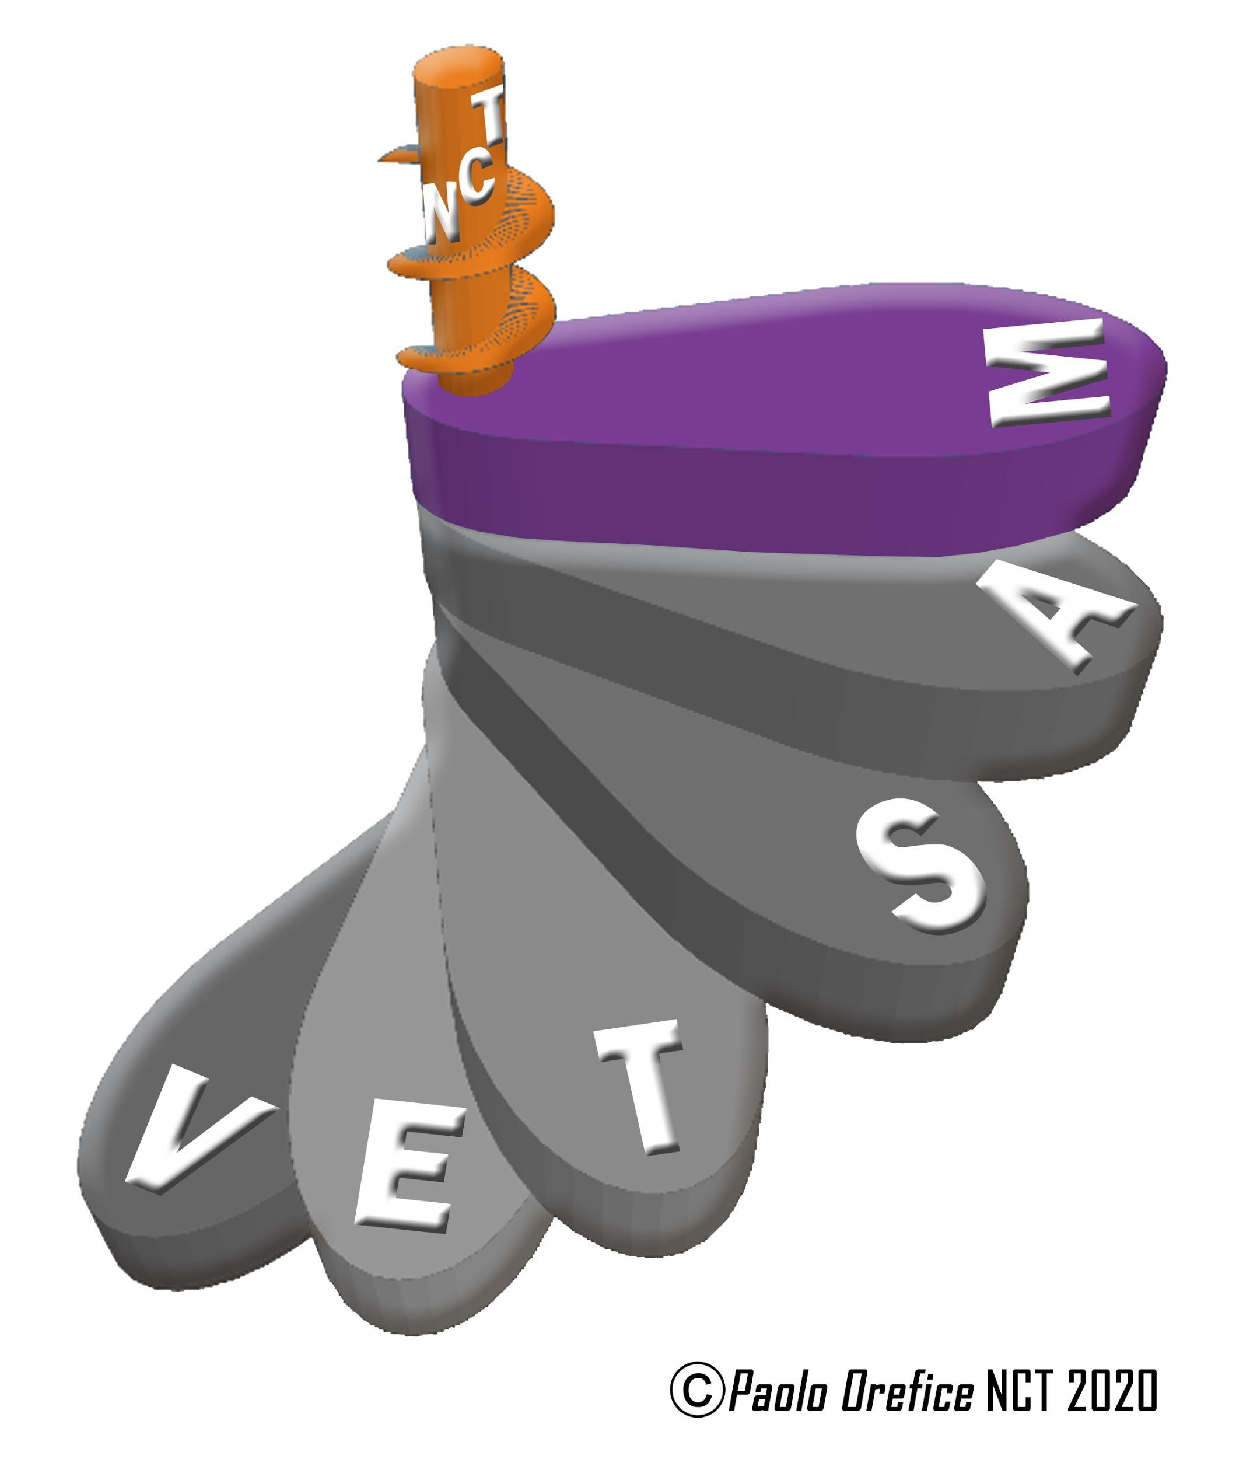
Presentation of Week: Mario Biggeri. University of Florence, Italy.
Moderator: Alberto Tonini. University of Florence, Italy.

KEYNOTE LECTURE
“TRANSDISCIPLINARY RESEARCH IN UNIVERSITY EDUCATION”
Lorenzo Fioramonti. Pretoria University, South Africa.
ROUND TABLE
“COMMUNITY EDUCATIONAL THEORIES AND PRACTICES”
Moderator: Alberto Tonini

"Knowledge sharing: experiences of African schools".
Abdoulaye Konté. Network for the emergence and development of ecovillages in the Sahel, Senegal.
Intellectual deficiency and the world of work. Paths to transdisciplinarity in an international research Portugal and Brazil
Anderson Spavier . Special Education Center (CEEBA), Bahia, Brazil.
"Educational approach: ‘sentipensares’ and community practices".
Pedro Reygadas Robles Gil. Indigenous Intercultural University of Michoacán, Mexico.

"The network of Universities for Peace from the perspective of participatory professionals".
Alberto Tonini. University of Florence, Italy.

FRIDAY, JULY 16, 2021
CTU, ITALY
PARTICIPATORY RESEARCHERS.
THE REASERCHER AS A CHANGE IN THE RELATIONSHIP BETWEEN SUBJECT / OBJECT
SYMPOSIUM
“THE SPACE / TIME SUSTAINABLE COMMUNITY EDUCATIONAL
FROM THE MOTER PROJECT (TERRITORIAL MODEL OF EDUCATIONAL AND DIDACTIC PROGRAMMING) TO THE TRANSDISCIPLINARY PARTICIPATORY ACTION RESEARCH (IAPT)"
Moderator: Paolo Orefice
Educational communities of the terrestrial citizenship: defoliating of the knowledges in the IAPT
Paolo Orefice. CTU, University of Florence. Italy.

Participatory Action-Research as a methodology for the management of integral local human development
Rodolfo Glenton. CTU / University of Florence, Italy.

"The Moter Project: Territorial model of educational programming in the Flegrea area". Vincenzo Sarracino. Suor Orsola Benincasa University, Italy.

"MOTER. Territorial model of educational programming. The Monte di Procida experience.
Franco Valenti. MOTER, Naples, Italy.

Novoli: IAPT for the integration of intangible and tangible dimensions in sustainable urban development
Stefania Vitali. Arq, CTU Attaché, University of Florence, Italy
Piero Osti. President of the NovoliBienComún Association, Florence, Italy

The rhythms of life in Piazza Santa Croce. An experience of didactica of the environment.
Roberta Milli and other teachers. Scholastic Institute "Scuola- Città Pestalozzi", Florence, Italy

"The house in the tree: what elements of sustainable living? Towards a transdisciplinary curriculum".
Enza Varagone. Iva Pacetti Scholastic Institute, Prato, Italy.

WEDNESDAY, JULY 21, 2021
CIRET, FRANCE
WHAT WORLD FOR TOMORROW CAN WE IMAGINE IN THE LIGHT OF THE CORONAVIRUS PANDEMIC?

KEYNOTE LECTURE
“SUMMARY OF THE CIRET DEBATE ON THE SUBJECT: WHAT WE LEARN FROM THE CORONAVIRUS CATASTROPHE?”
Basarab Nicolescu. CIRET, France.
Florent Pasquier. CIRET, France.

ROUND TABLE
“WHAT WORLD FOR TOMORROW CAN WE IMAGINE IN THE LIGHT OF THE CORONAVIRUS PANDEMIC?”

"The roots of this crisis are in the man’s heart".
Philippe Dautais. Sainte-Croix Center in Dordogne, France.

"On the uncertainty of our certainties".
Roxana Bauduin. University of Versailles, France.

"The coronavirus revolution".
Magda Carneci. Poet, Ensaist, Romania

"Thinking awry"
David Appelbaum. Philosopher, USA.
Florent Pasquier (Président du CIRET). Conclusions.

FRIDAY, JULY 23, 2021

CIRET, FRANCE
WHAT WORLD FOR TOMORROW CAN WE IMAGINE IN THE LIGHT OF THE CORONAVIRUS PANDEMIC?

SYMPOSIUM
“WHAT WORLD FOR TOMORROW CAN WE IMAGINE IN THE LIGHT OF THE CORONAVIRUSPANDEMIC?”
Moderators: Basarab Nicolescu / Florent Pasquier

"The Systematization of Integralism and the re-Systematization of the World. Integralist-transdisciplinary benchmarks for educational systems".
Lucia Muresan. Romania.

"And with regard to the world to come, will the Sensitive Body take back its rights?".
Margarita de Vivero Zuber. Peru.

Prophets without robes or sticks: Hammarskjöld, Havel, Mandela, Thunberg
Roger Lipsey. EUA.
"When a virus disrupts the world".
Thierry Magnin. France.

WEDNESDAY, JULY 28, 2021

REDES, AFRICA
CULTURE OF PEACE AND SUSTAINABLE DEVELOPMENT
Moderator: Paolo Orefice
UTC, University of Florence, Italy.

ROUND TABLE
"CONSTRUCTION OF PEACE"

"Can the world build a Lasting Peace?"
Saliou Sakho, Senegal

" For an International Citizenship Education”
Abdoulaye Konté, Senegal

«Social Changes, Development and Peace"
Moustapha Casset, Senegal

"International initiatives for the evolution of women's rights in the fight against violence"
Barbara Pozzo. C. UNESCO, University of Insubrie, Come, Italy

FRIDAY, JULY 30, 2021

REDES, AFRICA
CULTURE OF PEACE AND SUSTAINABLE DEVELOPMENT
Moderator: Cristina Giudici
UNESCO Chair, University of Roma La Sapienza, Italy.

SYMPOSIUM
“INTERNATIONAL ORDER AND PEACE”

Africa faces the challenges of peace and sustainable development.
Ibou NGOM
Professor, Director of the Liceo Bambey Sérére,
Member of GEN Afrique,
Coordinator of the ECOLYCO Project

" Biodiversity for Peace"
Fatimatou Ndiaye, Sociologist and Geographer.
President and Founder of the B4P Movement, Biodiversity for Peace.
Peace and Development
Pape Daouda Gaye
Professor, Promoter of Local Development

WEDNESDAY, AUGUST 4, 2021
CETRANS, BRASIL
NATIVE PEOPLES OF BRAZIL. ANCESTRAL AND CURRENT CULTURE
MODERATORS: Vicente Goes and Martha de Lima

KEYNOTE LECTURE
The Indigenous Worldview and Sustainability.
Kaka Werá. Writer, Member of the International College of Therapists, founder of Instituto Arapoty, social entrepreneur of the Ashoka Network of Social Entrepreneurs.
ROUND TABLE

Indigenous Cinema.
Hugo Fulni-ô. Filmmaker and short film editor, founder of “Coletivo Fulni-ô de Cinema”. Master’s degree in Humanities - Language and Linguistics from the University Federal of Alagoas – UFA.

Indigenous Visual Arts.
Daiara Tukano. Master’s degree in Human Rights from the University of Brasília – UNB; research field: indigenous peoples right to memory and truth.

Laklãnõ Indigenous Land and Indigenous Territory: Village, City and University.
Walderes Cocta Pripra. Master’s degree in History, major in Archeology, Ethnohistory and Indigenous History from the University Federal of Catarina – UFSC.

FRIDAY 6 AUGUST 2021
CETRANS, BRASIL

SYMPOSIUM

NATIVE PEOPLES OF BRAZIL AND THEIR RELATION TO NATURE AND TO THE PLANET EARTH
MODERATORS: Vicente Goes and Martha de Lima

The Indigenous Territories of the Atlantic Forest and the Green Belt as Good Living in the Planet
Kerexu Yxapyry. Graduated in Indigenous Intercultural Studies from University Federal of Santa Catarina – UFSC, indigenous leader of the “Morro dos Cavalos”, Indigenous land in Santa Catarina, Executive coordinator of the Articulação dos Povos Indigenas do Brasil –APIB, and of the Comissão Guarani-Yvyrupá.

Indigenous Resistance Strategies Nowadays
Joziléia Kaingang. PhD student in Social Anthropology at the – PPGAS/UFSC, Anthropologist, co-councilor at the Collective Bem Viver/PSOL, in the city of Florianópolis/SC, Founding member of the Associação Brasileira de Indigenas Antropólogos.

Indigenous Speech as means to Transformation
Célia Xakriabá. Master’s degree in Sustainable Development from the University of Brasília, PhD student in Anthropology at the Federal University of Minas Gerais, Leadership in the Articulação Nacional das Mulheres Indígenas.

WEDNESDAY, AUGUST 11, 2021
TRANSDISCIPLINARY SYMPOSIUM
ECO-DIALOGUE AND HUMAN SUSTAINABILITY
ECODIALOGUE CENTER :
CO-CREATING TRANSDISCIPLINARY DIALOGIC CARE"
Moderator and Coordinator: Enrique Vargas Madrazo
"Human Sustainability and Participation from Dialogue".
Enrique Vargas Madrazo. EcoDialogue Center Coordinator.

"Contemplative attitude and transdisciplinary epistemological vigil".
Antonio Gómez Yepes. Metabolic Therapies, Xalapa, Mexico.

"The excited word as an interior-exterior relationship in knowledge".
Silvano Héctor Rosales Anaya. UNAM, Mexico.

“Being, Touching, Feeling: Moving in a transdisciplinary dialogic dance”.
Laura Montoya Hernández. Center for Transdisciplinary Research on Regional Development, University Autonomous of Tlaxcala.

“The mise in abyme or how the paradox is handled in literature.”
Francesco Panico. EcoDialogue Center – SEA, University Veracruzana,
Mexico.

FRIDAY, AUGUST 13, 2021
TRANSDISCIPLINARITY AND NEUROSCIENCES,
Moderadora: Marisol Cárdenas Oñate
KEYNOTE LECTURE
FALLING UP: THE COMPLEXITY RATCHET PARADOX IN EVOLUTION
Terrence W. Deacon
University of California, Berkeley, USA.

MODERATOR: José Luis Valencia González
National School of Anthropology and History
KEYNOTE LECTURE

"NEUROMATHEMATICS AND NEUROSCIENCES,
A NEW WAY TO TEACH MATHEMATICS "
Juan Moisés de la Serna. Spain
KEYNOTE LECTURE
HISTORICAL MEMORY OF THE FALL OF
TENOCHTITLAN, 1521
Eduardo Matos Moctezuma
Coordinator of the Templo Mayor Project, INAH, Mexico
in front of the 500 years of the Anahuaca Resistance
José Luis Valencia González, National School of Anthropology and History.

WEDNESDAY, AUGUST 18, 2021
TRANSDISCIPLINARITY, DECOLONIALITY, FEMENISMS
Moderator: Marisol Cárdenas Oñate

KEYNOTE LECTURE
“DECOLONIZE FEMINISM?”
Eli Bartra Muria. UAM-Xochimilco, Mexico.

"Warmi Kawsaymanta: indigenous women and gender perspective in the South American Andes. A critical and integrative look at the complexity of the theme".
Martha Santillán. Ministry of Foreign Affairs and Human Mobility, Ecuador

"Opera about violence against rural women. A polyphonic ethnography in complexity and transdisciplinarity".
Guadalupe Huacuz. UAM-Xochimilco, Mexico.

"From feminism and transdisciplinarity: Challenges that cannot be postponed for women's health".
Yuriria A. Rodríguez Martínez. Gender, Society and Human Rights Academic Community. IES Monterrey, Mexico.

"Feminism and the Coloniality of Technology"
Paola Ricaurte Quijano. Instituto de Estudios Superiores de Monterrey ITESM
Campus Mexico City.

FRIDAY, AUGUST 20, 2021

TRANSDISCIPLINARITY, DECOLONIALITY

SYMPOSIUM
“TRANSDISCIPLINARY PERSPECTIVES AROUND DECOLONIAL TURN”
Moderator: Gustavo Aviña Cerecer

"Liberation and decolonial turn. Crossover or foundation?".
Stefano Santasilia. School of Social Sciences and Humanities, UASLP, Mexico.

"Nationalism, race and coloniality".
Perla Navarro. School of Social Sciences and Humanities, UASLP, Mexico.

"Dialectics of Empire: Necrocapitalism and Decoloniality".
Gustavo Aviña Cerecer. School of Social Sciences and Humanities, UASLP, Mexico.

"Decolonial educational possibilities, higher level".
Raúl Jiménez. School of Habitat, UASLP, Mexico.

"Artivism and collective action in Latin America".
José Antonio Motilla. School of Habitat, UASLP, Mexico.

WEDNESDAY, AUGUST 25, 2021

REAL WORLD MULTIVERSITY EDGAR MORIN MEXICO

KEYNOTE LECTURE
"CHAOS AND CULTURAL CONTENTIONS"
ROBERTO RIVERA PÉREZ
TRANSDISCIPLINARITY IN EDUCATION. TRAINERS FOR THE XXI CENTURY
MODERATOR: ROBERTO RIVERA PÉREZ

Transdisciplinarity in Education. Trainers for the 21st Century
Katherine Ingrid Rico Reintsch
Transdisciplinarity as a Transformation of Education in the 21st Century
Adriana María Ruiz Restrepo
Complexity and professionalization of teachers. The current context of basic education in Mexico
Maria Guadalupe Alvarez Nieto

FRIDAY 27 AUGUST 2021
REAL WORLD MULTIVERSITY EDGAR MORIN
UNIVERSITY OF CHIHUAHUA, MEXICO
HIGHER NORMAL SCHOOL OF THE STATE OF MEXICO
SYMPOSIUM
CHALLENGES OF HIGHER EDUCATION, COMPLEX THINKING AND TRANSDISCIPLINARITY
MODERATOR
ISRAEL SANDRE OSORIO
RESEARCH PROFESSOR OF REAL WORLD MULTIVERSITY EDGAR MORIN

Higher Education And Complex Thinking. Paradigmatic Challenges And Struggles
Rigoberto Pupo Pupo Professor Emeritus, Phd Honoris Causa
Multiversity Real World Edgar Morin, Mexico

Challenges Of Transdisciplinarity In The Approach Of Higher Education During The Pandemic. The Case Of The University Institute Of Peace
Oscar Orlando Porras Atencia, Rector Of The University Institute Of Peace-UNIPAZ.
The Education Between The Dialogue Of Rationalities And Knowledges
José Luis Martínez Díaz
Chief Of The Department Of Investigation, Educational Innovation And Postgraduate, Teacher Education School Of The State Of Mexico
Research Processes In Normal Schools Of The Department Of Caldas
Oscar Mario Grisales
Escuela Normal Superior “Claudia Munera” de Aguadas,Caldas, Colombia
Literature And History: The Necessary Transdisciplinary Crossing
Ramón Gerónimo Olvera Neder and Federico Mancera Valencia
Research Professors at the Autonomous University of Chihuahua, Mexico

WEDNESDAY, SEPTEMBER 1, 2021
IBERO-AMERICAN UNIVERSITY, MEXICO
"TRANSDISCIPLINARITY AND UNIVERSITY:
RESOLUTION OF COMPLEX SOCIAL PROBLEMS "
Coordinators: Sylvia Schmelkes Del Valle
Luis Javier Cuesta Hernandez

KEYNOTE LECTURE
"TRANSDISCIPLINARITY VS COMPLEX SOCIAL PROBLEMS"
Alejandro Guevara Sanginés. Universidad Iberoamericana - University Transdisciplinary Center for Sustainability

ROUND TABLE
"ADVANTAGES, STRATEGIES AND VALUES OF TRANSDISCIPLINARITY: DIVERSE VISIONS"
Moderator: Sylvia Schmelkes Del Valle. Ibeoamerican University
"Transdisciplinary as responsive research".
Ulli Vilsmaier. Leuphana Universität.

"Interdisciplinary work: a pillar of the research with the Ibero Seal".
Marisol Silva Laya. Ibeoamerican University.

"The construction of strategies and possibilities for the training of education professionals in educational research from a transdisciplinary perspective".
Irma Alicia Flores. University of the Andes.

"The construction of the common from and for diversity".
Julianna Merçon. Veracruz University.

FRIDAY, SEPTEMBER 3, 2021

IBERO-AMERICAN UNIVERSITY, MEXICO
"TRANSDISCIPLINARITY AND UNIVERSITY:
RESOLUTION OF COMPLEX SOCIAL PROBLEMS "

SYMPOSIUM:
"UNIVERSITY AND TRANSDISCIPLINARITY:
STRUCTURAL RESISTANCES AND NEW PROPOSALS "
Moderator: Luis Javier Costa

"The Doctorate in Critical Gender Studies: an interdepartmental and transdisciplinary approach".
Manuel López Pereyra. Iberoamerican University.

"Where does Transdisciplinarity in Latin America come from?"
Adriana Flores Díaz. Iberoamerican University.

"Transdisciplinary approach and curriculum in inequality studies: a proposal for an academic program".
Irving Rosales Arredondo. Iberoamerican University.

"The management model of the University Transdisciplinary Center for Sustainability (CENTRUS)".
Juan Manuel Núñez Hernández. Iberoamerican University.

WEDNESDAY, SEPTEMBER 8, 2021
OPEN SCIENCE AND THE DECOLONIZATION OF KNOWLEDGE
Coordinators: Rajesh Tandon and Budd Hall
KEYNOTE LECTURE
INDIGENOUS WAYS OF KNOWING AND THE CHALLENGES OF THE 21ST CENTURY
Lorna Wanot’sa Williams
ROUND TABLE
Moderator-Opening Remarks: Budd Hall
University of Victoria, Canada
"Transdisciplinarity, IKS and Restorative Action: Implications for Open Science.”
Catherine Odora-Hoppers, Gulu University, Uganda. (15min)

"Community policy agenda setting through equitable partnership in Sassari, Sardinia”.
Andrea Vargiu. Sassari University. (15min)

"Towards Bibliodiversity and Open Knowledge Infrastructure."
Leslie Chan, Knowledge Equity Lab, University of Toronto Scarborough, Canada. (15min)

"Open school to the democratization of knowledge, open school for peacebuilding”.
Irma Flores. University of the Andes, Bogotá, Colombia. (15min)
Knowledge democracy for the Earth Citizenship

Reality and Knowledge development in TPAR ( Transdisciplinary Participatory Action Research)
Paolo Orefice. CTU Chair Holder University of Florencia, Italy.
Q & A (15min)
Closing remarks by Budd Hall, University of Victoria, Canada.

FRIDAY, SEPTEMBER 10, 2021

SYMPOSIUM
“DECOLONIZATION AND THE KNOWLEDGE FOR CHANGE CONSORTIUM: CHALLENGES AND HOPES”
Opening Remarks, Moderator: Rajesh Tandon, Co-Chair (10min)
Co-Moderator: Niharika Kaul

"Insights from the History Below, from the Knowledge for Change Consortium".
Rajesh Tandon. Founder-President, PRIA, and Co-Chair of UNESCO Chair in Community-Based Research and Social Responsibility in Higher Education (15 minutes)

"Complexity and Transdisciplinarity in University Formation and Research: a Needed Transition".
Sylvia Schmelkes. Universidad Iberoamericana, Mexico.

"Immigrant women researching their own lives in Tkaronto, Canada"
Karen Villanueva. Community Learning Centre, Toronto, Canada.

Q&A (25min)
Closing Remarks. Rajesh Tandon, PRIA and Co-Chair of UNESCO Chair in Community-Based (10min)

WEDNESDAY, SEPTEMBER 15, 2021

KEYNOTE LECTURE
PANDEMIC: IDENTITY IN EXTINCTION
Karina Bustos, Giampiero Finocchiaro & Carlos Jesús Delgado. AlunCo Institute, Argentina.
ROUND TABLE
PLASTICITY & TRANSDISCIPLINARITY. AN EXPERIENCE AT CROSSROADS HUMAN SCIENCES, ARTS.
Moderator: Marc Williams Debono

KEYNOTE LECTURE
"Changing cultures & Transdisciplinary issues of the plasticity concept".
Marc-Williams Debono. PSA, CIRET, France.

Phenomenological approach to art in a natural environment

Patricia PROUST-LABEYRIE (PSA, CIRET, FRANCE)

"Ouroboros and the nature of post-disciplinary fields: archeology and ecology beyond transdisciplinarity".
Luiz Oosterbeek. CIPSH-UNESCO, Polytechnic Institute of Tomar, Portugal.

Emotions, Human energy and the Plasticity of mind.
Mariana THIERIOT-LOISEL (CIRET, CETRANS, UNIFIEO, Brazil - Canada) & Frederic Andres (National Institute of Informatics, Tokyo, Japan)

FRIDAY, SEPTEMBER 17, 2021
ICONOS, MÉXICO

SYMPOSIUM
"TRANDISCIPLINARITY AND EXPONENTIAL DIGITAL TECHNOLOGIES"
Moderator: José Luis Valencia

"Exponential digital technologies from transdisciplinarity and sustainability".
José Rafael Mauleón Rodríguez.

"Transdisciplinarity in human contact and connection in the Fourth Industrial Revolution".
Adriana Barragan.

"Eroticism and the third party included: metaverses and love".
Ileana Diaz.

"The avatar behind the monitor. The transdisciplinarity in the construction of an image for virtual education"
Tiberio Zepeda.

"Mentalities and transdisciplinarity in disruptive digital technology environments".
Roselena Vargas.

WEDNESDAY, SEPTEMBER 22, 2021
CHINA AND ITALY
Event in partnership with UNESCO Chair on Health Education and Sustainable Development

SYMPOSIUM
“HEALTH BENEFITS OF MEDITERRANEAN DIET
and CHINESE NUTRITIONAL HABITS”
Opening Remarks: Prof. Annamaria Colao, UNESCO Chair on Health Education and Sustainable Development & President of the Italian Society of Endocrinology
Moderator: Prisco Piscitelli MD PhD, Chair (10 min)

KEYNOTE LECTURE: "Mediterranean Diet and Health Benefits: Updated Scientific Evidence" Prof. Antonia Trichopoulou, Hellenic Health Foundation, Athens (30 min)

KEYNOTE SPEECH: “How Mediterranean Diet influences human metabolism”
Dr. Giovanna Muscogiuri, University of Naples Federico II (20 minutes)

KEYNOTE SPEECH: “Health properties of Chinese traditional diet”
Prof. Chaoming Weng, Department of Life Sciences, Beijing University (20 minutes)

KEYNOTE SPEECH "Social and Cultural Determinants of Chinese Nutritional Habits” Prof. Shen Chen, Chinese Academy of Social Sciences (20 minutes)

KEYNOTE SPEECH “Circular Bioeconomy and Sustainable Food Production”.
Prof. Annalisa Santucci, University of Siena, Italy (20 minutes)

Q&A (30 min)
Closing Remarks. Prof. Antonia Trichopoulou (10 min)

FRIDAY, SEPTEMBER 24, 2021

CHINA AND ITALY
Event in partnership with UNESCO Chair on Health Education and Sustainable Development

ROUND TABLE
“WHAT WE CAN LEARN FROM CHINESE TRADITIONAL MEDICINE?”
Opening Remarks/Moderator: Prisco Piscitelli MD PhD – Chair (10 min)

“The Art of Traditional Chinese Medicine”
Prof. Anlong Xu, Dean of Beijing University of Chinese Medicine (30 min)

“The Theory and Practice of Chinese Traditional Medicine
in keeping harmony between Human and Nature”
Dr. Chaoming Weng, Dept. of Life Sciences, Beijing University of Chinese Medicine (30 min)

“Universal Principles of Toxicology and Pharmacology”
Alberto Ritieni, University of Naples Federico II (30 min)

“Pharmaceutical Applications of Chinese Traditional Medicine: what opportunities?”
Nicholas Ainslie, LSA and GT Research, California, USA (30 min)

Q&A (30 min)
Closing Remarks. Prof. Annamaria Colao, UNESCO Chair on Health Education and Sustainable Development & President of the Italian Society of Endocrinology (10 min)

WEDNESDAY, SEPTEMBER 29, 2021
ARAB COUNTRIES AND ITALY
COORDINATION COMMITTEE UTC ITALY
Creative cities for the urban and territorial regeneration of post-Covid local educational societies for the SDGs
Coordination Fabriano Creativa
National coordination of Italian Creative Cities UCCN
The antifragile creative city: experience in the UNESCO network
17 pm MODERATOR Vittorio Salmoni
Coordinator of the Italian Creative Cities UCCN
Opening of the proceedings
- President 3CMT prof. Julieta Haidar
- Min. Plenip. Dr. Enrico Vicenti

17.15 pm Introduction to the proceedings
- Gabriele Santarelli, Mayor of Fabriano
- Francesca Merloni Goodwill UNESCO Ambassador
- Vittorio Salmoni, Focal Point Fabriano Creativa, UCCN National Coordinator
The antifragile city: effects of the Annual Conference, UCCN 2019

17.40 pm Report:
Ahmed Al-Matard Focal Point,
Al-Ahsa Creative City of Crafts UCCN. The Al-Ahsa experience

18.25 Round Table: The programs of the Italian Creative Cities post Covid 19 Moderator Vittorio Salmoni
- Paolo Orefice, Prof. Em., Chairholder of UTC, University of Firenze
Sustainable regeneration of the knowledge of the educational community.

- Federica Forti , Carrara UCCN, City of Crafts and Folk Art The Carrara Charter

- Barbara Greggio Biella UCCN, City of Crafts and Folk Art. Biella Green Deal

- Andrea Bortolamasi , Modena, City candidate for UCCN Media Arts
The candidacy project for UNESCO

19.40pm / 20.00pm Work closes
Massimo Sargolini School of Architecture and Urban Planning, University of Camerino. The antifragile territories of the Central Apennines.

FRIDAY , OCTOBER 1 , 2021
ARAB COUNTRIES AND ITALY
COORDINATION COMMITTEE UTC ITALY
SYMPOSIUM
Cultural, social and educational regeneration of the sustainable city: research and experiences in the Mediterranean area
H 17 Presentation and Coordination Paolo Orefice ,Prof. Em., Chairholder of UTC, University of Florence

H 17, 20 Mohsen Aboulnaga, Prof. Dr., Cairo University, Egypt
Foster Sustainability through Interdisciplinary Approach in Urban Development to Attain SDGs — Egypt’s Experience and Projects

H 17, 45 Paola Puma, Prof., Department of Architecture, University of Florence Stefania Vitali, Arch., UTC Adjunct Member
Culture and resilience in the post-COVID city
Tunisia, a citizen journey for cultural, social and urban regeneration
H 18.10 Mrs. Afef Hagi PhD- president of the Pontes Recherches et Interventions Association, Tunis/Florence
Citizen engagement for the rebirth of a popular district of Tunis

H 18.35 Mme Ouejdane Mejri PhD in planning, design and urban policies of the Polytechnic of Milan, Pontes Recherches et Interventions Association, Tunis/Florence
Spatial and social transformations of the Medina of Tunis

H 19 Mohamed Amine Ben Said, Citizen Architect, Association for Buildings and Memories
Development of Historic Districts in Tunisia: Alternative and Citizen Approach. Civil society / institutions experiences and interaction

H 19,25 Nitamo Federico Montecucco, Dr.MD., President of Social Promotion Association Villaggio Globale, Bagni di Lucca
From cities to global citizenship: a transdisciplinary educational program for sustainable development.

H 19.35 Questions and answers
H 20.00 Closing of the week

WEDNESDAY, OCTOBER 6 2021
INDIA, INDONESIA, ITALY
UNESCO CHAIRS I AND CH
TRANSDISCIPLINARITY AND HERITAGE IN THE NGALSO TRADITION
OPENING
Aldo Marzano, President of the Italian Buddhist Union
Gabriella Lo Re General coordinator Albagnano Healing Meditation Center
Dra Anna Siri, Member UNESCO Chair of Genoa, Italy
Carolina Guidi, UNESCO Chair USI Lugano
KEYNOTE LECTURE
The Scarpa Museum of Genoa and the UNESCO Chair Project of Anthropology of Health at Albagnano
Antonio Guerci – UNESCO Chair of Genoa, Italy
KEY NOTE LECTURE
NgalSo tradition at Albagnano
Lama Michel Rinpoche – AMHC Albagnano

ROUND TABLE
"Material landscape and ancestral memory at Albagnano – Sacri Monti"
Adine Gavazzi, UNESCO Chair of Genoa, Italy

"Intangible Heritage of NgalSo healing practices"
Tania Re, UNESCO Chair of Genoa, Italy

"NgalSo as Mind-Body medicine for mental Health"
Rogier Hoenders, NgalSo Research Group

"NgalSo practice in Public Health and Cancer prevention"
Paola Muti, NgalSo Research Group, Hamilton Ontario, Canada

CONCLUSIONS: ANTONIO GUERCI

FRIDAY OCTOBER 8 2021
INDIA, INDONESIA, ITALY

UNESCO CHAIRS I AND CH
TRANSDISCIPLINARITY, HERITAGE AND LANDSCAPE IN BOROBUDUR
PRESENTATION BOROBUDUR
Borobudur presentation
Shabaz Kahn, Director of the UNESCO office at Jakarta

"Transdisciplinarity and communication of Borobudur World Heritage Site"
Lorenzo Cantoni, UNESCO Chair of Lugano, Switzerland

ROUND TABLE
"Tibetan cosmological models in the Borobudur tradition"
Lama Caroline, AMHC Albagnano, Italy

"Archaeology and conservation in Borobudur"
Jose Bastante, Parque Arqueológico Nacional Machu Picchu, Peru

"Traditional knowledge in conservation at Borobudur"
Marsis Sutopo, Conservation Office of Borobudur

"Ceremonial architecture and sacred landscape at Borobudur"
Adine Gavazzi, UNESCO Chair Genova, Italy

"Traditional medicines and healing practices at Borobudur"
Tania Re, UNESCO Chair Genova, Italy

"Java ethnomedicine in the multicultural context of Borobudur"
Giovanni Perotti, UNESCO Chair Genova, Italy

"Health and Spirituality: A Transdisciplinary Perspective on Gender Equality in India".
Paulo Nuno Martins, University Fernando Pessoa, Porto, Portugal

CONCLUSIONS ANTONIO GUERCI

WEDNESDAY, OCTOBER 13 2021

TÉRMINO DEL CONGRESO VIRTUAL
ESTABLECER LOS DIAS IMPORTANTE

EN ELABORACIÓN

FRIDAY, OCTOBER 15 2021

TERMINO CONGRESO VIRTUAL
DIA 15 OCTUBRE 2021

DR. ARMANDO GONZÁLEZ SALINAS – RESPONSIBLE FOR THE ENGLISH VERSION OF THE PROGRAM

